

**Capstone Project Report**

**Report 3 – Software Requirement Specification**

– HoChiMinh, January 2025 –

**Table of Contents**

# I. Record of Changes

|  |  |  |  |
| --- | --- | --- | --- |
| Date | A*  M, D | In charge | Change Description |
| 06/02/2525 | A |  |  |
|  |  |  |  |
|  |  |  |  |
|  |  |  |  |
|  |  |  |  |
|  |  |  |  |
|  |  |  |  |
|  |  |  |  |
|  |  |  |  |
|  |  |  |  |
|  |  |  |  |
|  |  |  |  |
|  |  |  |  |

*A - Added M - Modified D - Deleted

# II. Software Requirement Specification

## 1. Product Overview

**Product Overview**

VinShuttle is an innovative electric vehicle booking application designed to streamline intra-area transportation within large residential communities, with a primary focus on Vinhomes Grand Park (VHGP) in Ho Chi Minh City. The platform addresses the inefficiencies and inconveniences of traditional transportation methods by providing a user-friendly, eco-friendly, and centralized solution for residents to book electric shuttles. By incorporating advanced features such as real-time tracking, route optimization, and seamless payment integration, VinShuttle enhances mobility while promoting sustainability within the community.

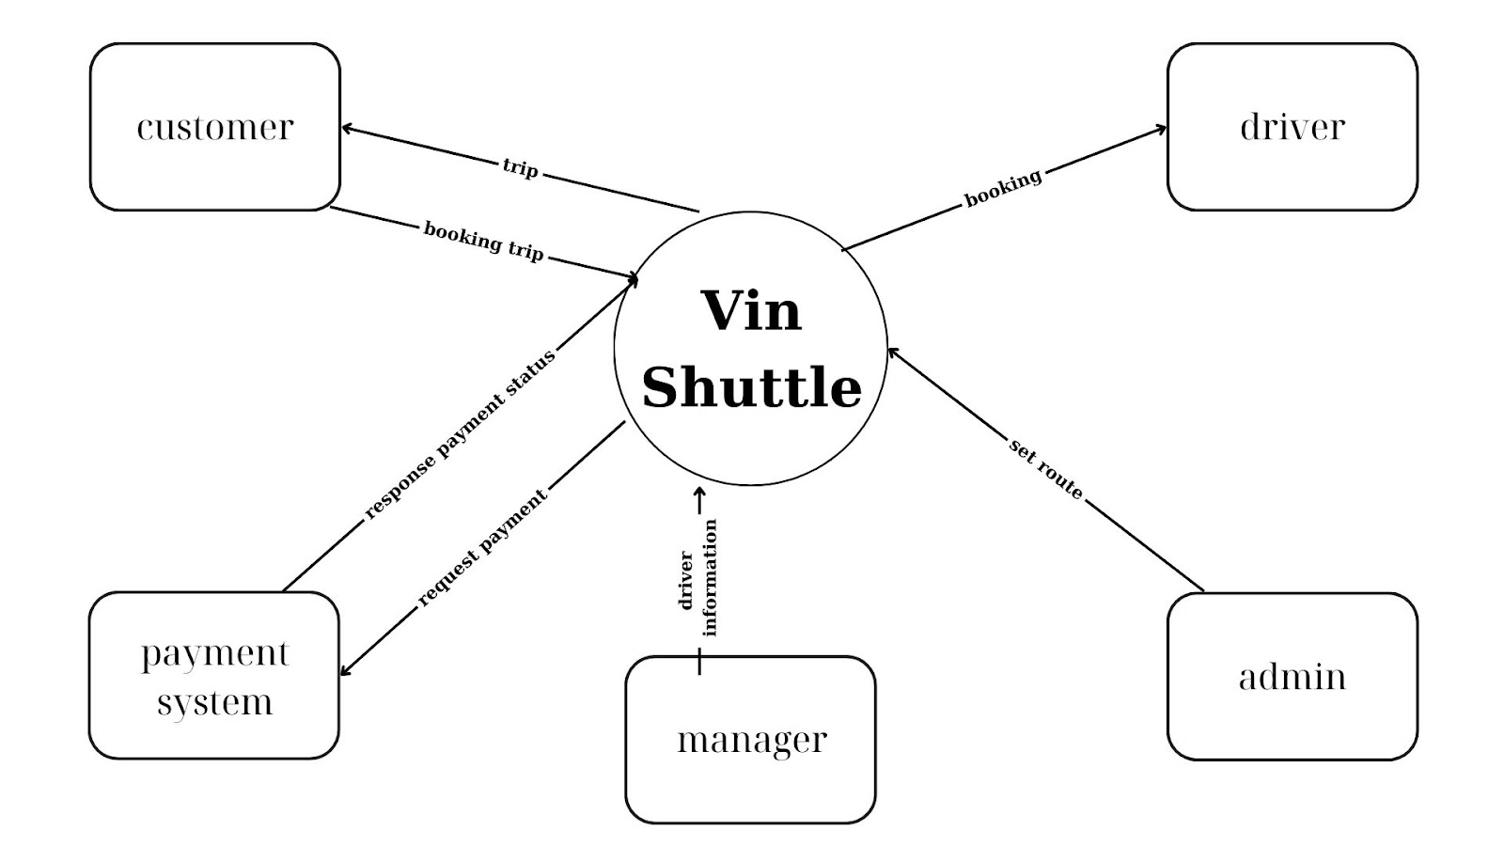

## 2. User Requirements

### 2.1 Actors

|  |  |  |
| --- | --- | --- |
| **#** | **Actor** | **Description** |
| 1 | Administrator | Who is responsible for managing the system and permission. |
| 2 | Manager | The Manager oversees drivers, customers, and bookings, managing schedules and feedback. |
| 3 | Customer | The Customer books rides, tracks trips, provides feedback, and manages their profile. |
| 4 | Driver | The Driver manages bookings, schedules, routes, and communication. |

### 2.2 Use Cases

#### 2.2.1 Diagram(s)

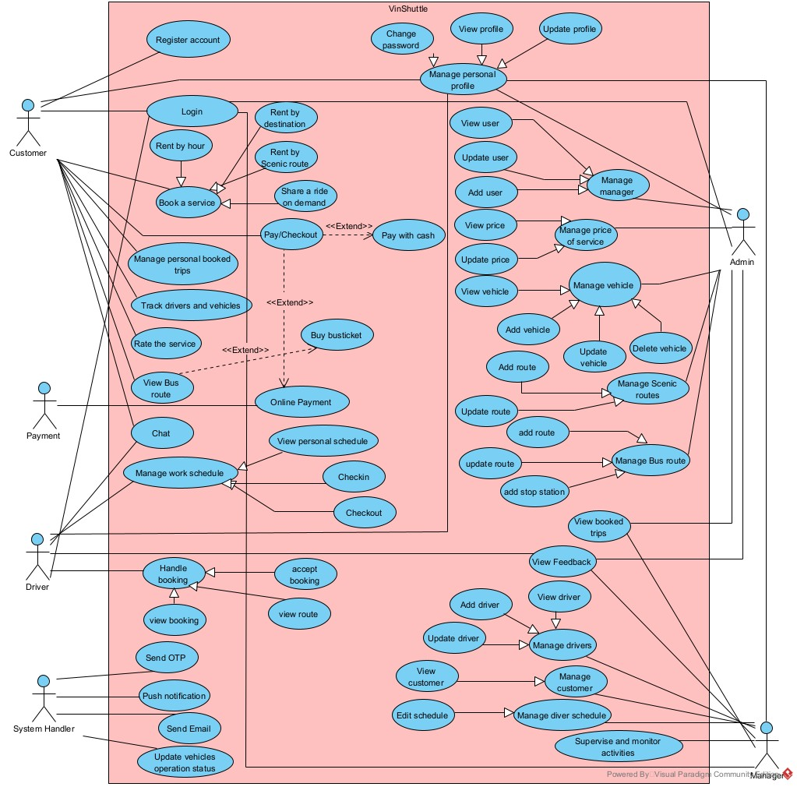

#### 2.2.2 Descriptions

|  |  |  |  |
| --- | --- | --- | --- |
| ID | Use Case | Actors | Use Case Description |
| UC01 | Register account | Customer | The customer creates a new account on the VinShuttle platform to access its services. |
| UC02 | Login | Customer, Driver, Manager, Admin | The user logs into the VinShuttle system using their credentials or OTP (for customers). |
| UC03 | Change password | Customer, Driver, Manager, Admin | The user updates their password to secure their account. |
| UC04 | View profile | Customer, Driver | The user views their personal profile details on the VinShuttle platform. |
| UC05 | Update profile | Customer, Driver | The user updates their personal profile information, such as name, contact details, or preferences. |
| UC06 | Book a service | Customer | The customer books an electric shuttle service, choosing from options like rent by hour, rent by destination, or scenic route. |
| UC07 | Rent by hour | Customer | The customer books a shuttle for a specific duration based on hourly rates. |
| UC08 | Rent by destination | Customer | The customer books a shuttle to travel to a specific destination within the community. |
| UC09 | Share a ride on demand | Customer | The customer shares a shuttle ride with others on demand to reduce costs and promote eco-friendly travel. |
| UC10 | Pay/Checkout | Customer | The customer completes the payment for their booked service using online payment methods or cash. |
| UC11 | Pay with cash | Customer | The customer opts to pay for the shuttle service with cash at the end of the trip. |
| UC12 | Buy bus ticket | Customer | The customer purchases a bus ticket for a specific route within the community. |
| UC13 | Rate the service | Customer | The customer provides a rating for the shuttle service after completing a trip. |
| UC14 | View bus route | Customer | The customer views available bus routes and schedules within the community. |
| UC15 | Chat | Customer, Driver | The customer and driver communicate via the in-app chat feature to coordinate trip details. |
| UC16 | Manage personal booked trips | Customer | The customer views and manages their booked shuttle trips, including cancellations or modifications. |
| UC17 | Track drivers and vehicles | Customer | The customer tracks the real-time location of drivers and vehicles during their trip. |
| UC18 | View personal schedule | Driver | The driver views their assigned work schedule, including upcoming trips and tasks. |
| UC19 | Check-in | Driver | The driver checks in to confirm the start of a trip or shift. |
| UC20 | Check-out | Driver | The driver checks out to confirm the end of a trip or shift. |
| UC21 | Handle booking | Driver | The driver views and manages customer bookings assigned to them. |
| UC22 | Accept booking | Driver | The driver accepts a booking request from a customer. |
| UC23 | View booking | Driver | The driver views details of their assigned bookings, including customer information and trip details. |
| UC24 | View route | Driver | The driver views the route for an assigned trip, including maps and directions. |
| UC25 | Send OTP | System Handler | The system sends an OTP to the customer for secure login or verification purposes. |
| UC26 | Push notification | System Handler | The system sends push notifications to users for updates, such as booking confirmations or trip status. |
| UC27 | Send email | System Handler | The system sends email notifications to users for confirmations, updates, or promotional offers. |
| UC28 | Update vehicles operation status | System Handler | The system updates the operational status of vehicles (e.g., available, in use, or under maintenance). |
| UC29 | View user | Admin | The admin views the list of registered users (customers, drivers, managers) on the platform. |
| UC30 | Update user | Admin | The admin updates user information, such as roles, permissions, or account status. |
| UC31 | Add user | Admin | The admin adds a new user (e.g., driver, manager) to the system. |
| UC32 | View price | Admin | The admin views the pricing structure for shuttle services and bus tickets. |
| UC33 | Update price | Admin | The admin updates the pricing for shuttle services or bus tickets based on operational needs. |
| UC34 | Manage service price | Admin | The admin manages the overall pricing strategy for services offered on the platform. |
| UC35 | View vehicle | Admin | The admin views the list of vehicles available in the system, including their status and details. |
| UC36 | Manage vehicle | Admin | The admin manages vehicle information, including adding, updating, or deleting vehicles. |
| UC37 | Add vehicle | Admin | The admin adds a new vehicle to the fleet for use in the system. |
| UC38 | Update vehicle | Admin | The admin updates vehicle details, such as model, status, or maintenance schedule. |
| UC39 | Delete vehicle | Admin | The admin removes a vehicle from the system if it is no longer in use. |
| UC40 | Manage scenic routes | Admin | The admin manages scenic routes, including adding or updating routes for customer bookings. |
| UC41 | Add route | Admin | The admin adds a new scenic route for customers to book. |
| UC42 | Update route | Admin | The admin updates details of an existing scenic route, such as path or description. |
| UC43 | Manage bus stop | Admin | The admin manages bus stops, including adding or updating stop locations. |
| UC44 | Add stop station | Admin | The admin adds a new bus stop station to the system. |
| UC45 | View booked trips | Manager | The manager views all booked trips within the system to monitor operations. |
| UC46 | View feedback | Manager | The manager views customer feedback and ratings to assess service quality. |
| UC47 | View driver | Manager | The manager views the list of drivers, including their details and status. |
| UC48 | Add driver | Manager | The manager adds a new driver to the system. |
| UC49 | Update driver | Manager | The manager updates driver information, such as contact details or work schedule. |
| UC50 | View customer | Manager | The manager views the list of customers using the platform. |
| UC51 | Manage driver schedule | Manager | The manager assigns or updates schedules for drivers to ensure efficient operations. |
| UC52 | Supervise and monitor activities | Manager | The manager oversees and monitors all activities on the platform to ensure smooth operations. |

## 3. Functional Requirements

### 3.1 System Functional Overview

#### 3.1.1 Screens Flow

##### 3.1.1.1Customer Screen Flow

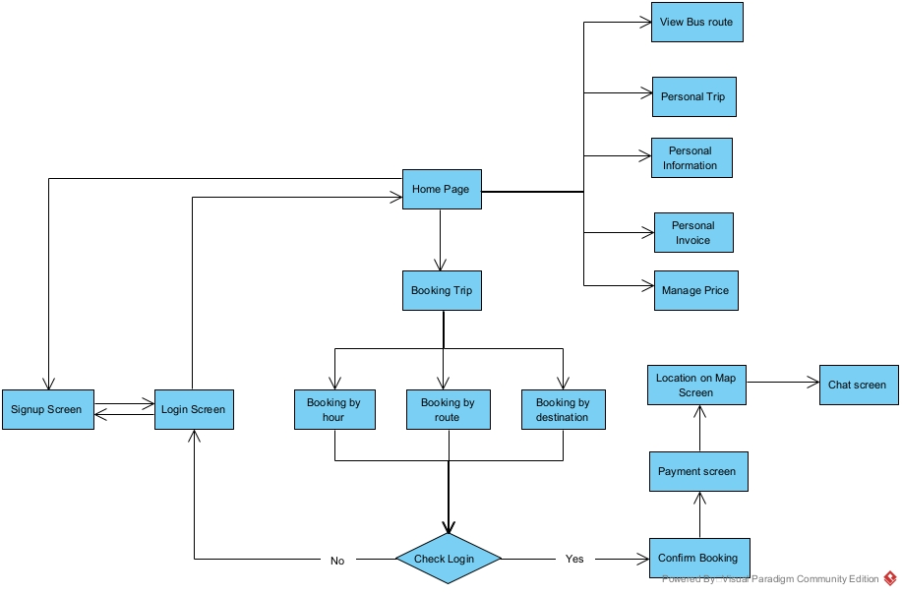

##### 3.1.1.2Driver Screen Flow

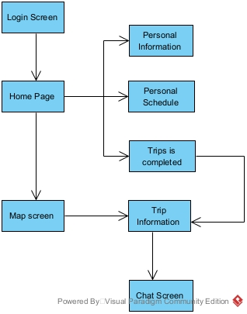

##### 3.1.1.3Manager Screen Flow

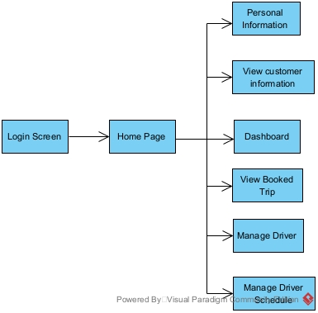

##### 3.1.1.4Admin Screen Flow

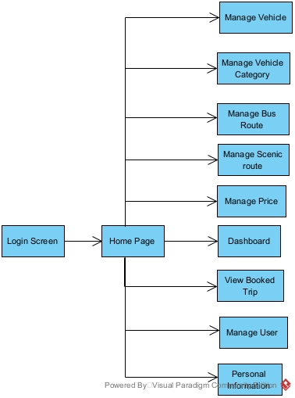

#### 3.1.2 Screen Descriptions

|  |  |  |  |
| --- | --- | --- | --- |
| **#** | **Feature** | **Screen** | **Description** |
| *Customer Screen Flow* | | | |
| 1 | Booking | Booking trip | Allows the user to choose the booking type |
| 2 | Booking | Booking by hour | Enables customers to book a trip based on hourly service. |
| 3 | Booking | Booking by route | Allows customers to book a trip following a predefined route, |
| 4 | Booking | Booking by destination | Enables customers to book a trip to a specific destination. |
| 5 | Booking | Confirm Booking | Final confirmation before completing the booking. |
| 6 | Chat | Chat screen | Allows customers to communicate with support or drivers. |
| 7 | Booking | Location on Map Screen | Displays the trip location and route on a map. |
| 8 | Logout | User Profile Screen | Allows customers to log out of the system |
| 9 | Show all services | Home Page | Allows customers to view services and navigate pages |
| 10 | Sign up | Signup Screen | Allows customers to sign up |
| 11 | Login | Login Screen | Allows customers to login |
| *Admin Screen Flow* | | | |
| 12 | Login | Login Screen | Admin authentication screen. |
| 13 | Navigate | Home Page | Main navigation hub |
| 14 | Management Vehicle | Manage Vehicle | Manage vehicle information |
| 15 | Management Vehicle Category | Manage Vehicle Category | Organize vehicle categories |
| 16 | Management Bus Route | Manage Bus Route | Configure bus routes |
| 17 | Management Scenic  Route | Manage Scenic  Route | Set up scenic routes |
| 18 | Dashboard | Dashboard | Overview of key metrics |
| 19 | Management Price | Manage Price | Configure pricing details |
| 20 | Management Users | Manage Users | Manage user accounts. |
| 21 | Profile | Personal Information | View and edit profile details. |
| *Driver Screen Flow* | | | |
| 22 | Login | Login Screen | Users log in to access the system. |
| 23 | Navigate | Home Page | The main hub for navigation to different features. |
| 24 | View Profile | Personal Information | View and update personal details. |
| 25 | View Schedule | Personal Schedule | Check assigned trip schedules. |
| 26 | Trips is Completed | Trip History | View the history of completed trips. |
| 27 | View Routes & Vehicles | Map Screen | Display vehicle locations and assigned routes. |
| 28 | Trip Details | Trip Information | View details of ongoing or upcoming trips. |
| 29 | Communication | Chat Screen | Communicate with other users or support. |
| *Driver Screen Flow* | | | |
| 30 | Login | Login Screen | Users log in to access the system. |
| 31 | Navigate | Home Page | The main hub for accessing management features. |
| 32 | View Profile | Personal Information | View and update personal details. |
| 33 | View Customer Details | View Customer Information | Access customer information and history. |
| 34 | Monitor System | Dashboard | View system analytics and key metrics. |
| 35 | View Booked Trips | View Booked Trip | See details of booked trips. |
| 36 | Manage Drivers | Manage Driver | Add, remove, or update driver details. |
| 37 | Manage Schedules | Manage Driver Schedule | Assign and modify driver schedules. |

#### 3.1.3 Screen Authorization

|  |  |  |  |  |  |
| --- | --- | --- | --- | --- | --- |
| # | Screen | Admin | Manager | Customer | Driver |
| 1 | Booking trip |  |  | ✓ |  |
| 2 | Booking by hour |  |  | ✓ |  |
| 3 | Booking by route |  |  | ✓ |  |
| 4 | Booking by destination |  |  | ✓ |  |
| 5 | Confirm Booking |  |  | ✓ |  |
| 6 | Chat screen |  |  | ✓ | ✓ |
| 7 | Location on Map Screen |  |  | ✓ | ✓ |
| 8 | User Profile Screen |  |  | ✓ | ✓ |
| 9 | Signup Screen |  |  | ✓ |  |
| 10 | Login Screen | ✓ | ✓ | ✓ | ✓ |
| 11 | Home Page | ✓ | ✓ | ✓ | ✓ |
| 12 | Manage Vehicle | ✓ | ✓ |  |  |
| 13 | Manage Vehicle Category | ✓ | ✓ |  |  |
| 14 | Manage Bus Route | ✓ | ✓ |  |  |
| 15 | Manage Scenic Route | ✓ | ✓ |  |  |
| 16 | Dashboard | ✓ | ✓ |  | ✓ |
| 17 | Manage Price | ✓ | ✓ |  |  |
| 18 | Manage Users | ✓ | ✓ |  |  |
| 19 | Personal Information | ✓ | ✓ | ✓ | ✓ |
| 20 | Personal Schedule |  |  |  | ✓ |
| 21 | Trip History |  |  |  | ✓ |
| 22 | Map Screen |  |  |  | ✓ |
| 23 | Trip Information |  |  |  | ✓ |
| 24 | View Customer Information | ✓ | ✓ |  |  |
| 25 | View Booked Trip | ✓ | ✓ |  |  |
| 26 | Manage Driver | ✓ | ✓ |  |  |
| 27 | Manage Driver Schedule | ✓ | ✓ |  |  |

#### 3.1.4 Non-Screen Functions

|  |  |  |  |
| --- | --- | --- | --- |
| **#** | **Feature** | **System Function** | **Description** |
| 1 | Send OTP | Send OTP via SMS | Send OTP via SMS to customer to verify when login by phone. |
| 2 | Send Email | Send Email to user | Send Email when manager create driver account, Invoice about booking,... |
| 3 | Push notification | Push notification to client | Push notification to user client when something new, status change,.. |
| 4 | Update vehicles operation status | Update vehicles operation status | Update vehicle operating status by time of day and work shifts. |

#### 3.1.5 Entity Relationship Diagram (cái này chưa xong)

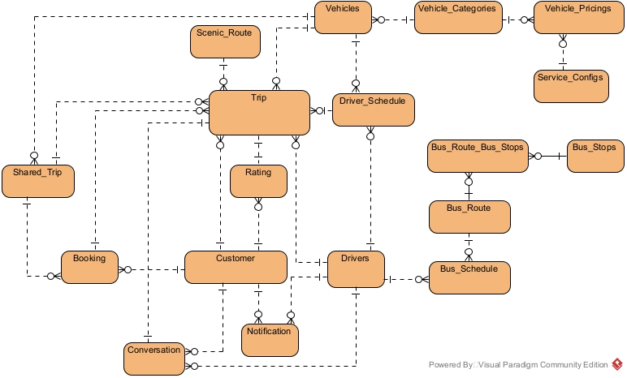

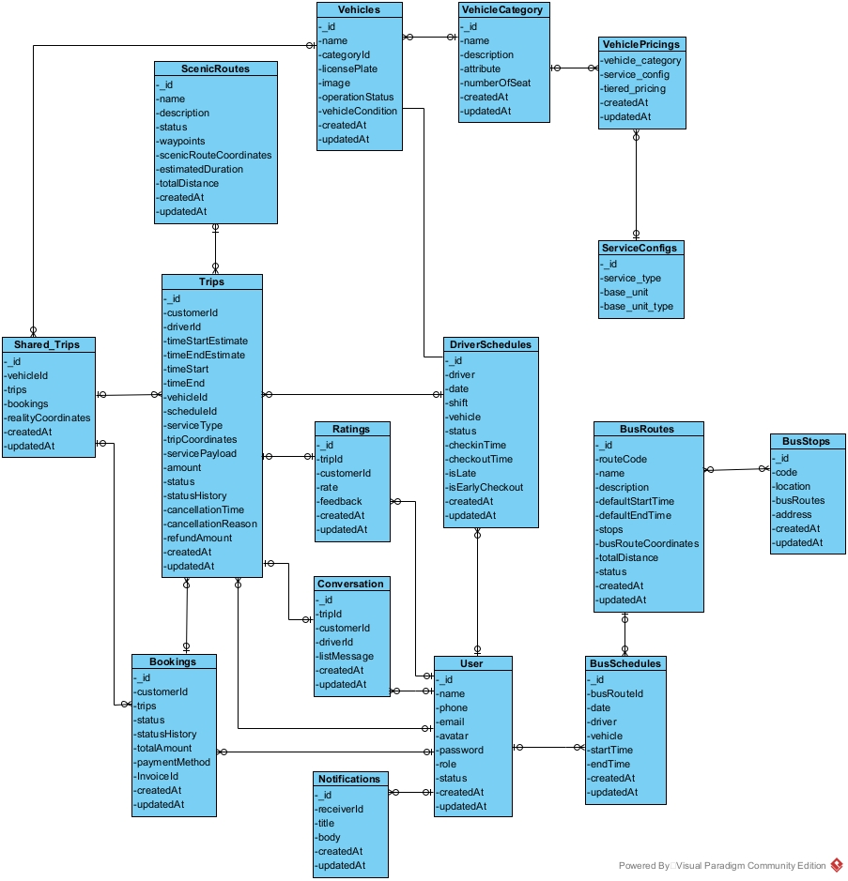

**Entities Description**

|  |  |  |
| --- | --- | --- |
| **#** | **Entity** | **Description** |
| 1 | Customer | Customer of the system |
| 2 | Drivers | Drivers of the system |
| 3 | Trip | A specific vehicle order from a single customer, recording information about time, driver, vehicle, and service details. |
| 4 | Booking | It is an overall transaction, focusing on recording payments and managing multiple "Trips" created at the same time from a single customer booking. |
| 5 | Vehicles | Vehicles of the system |
| 6 | Vehicle_Categories | Vehicle Categories of the system |
| 7 | Vehicle_Pricings | regulations on price ranges of vehicles and services of system |
| 8 | Service_Configs | regulations on types of units and standard units to calculate the price of each type of service of system |
| 9 | Driver_Schedule | Driver Schedule by shift of system |
| 10 | Bus_Route | Bus Route of the system |
| 11 | Bus_Stops | Bus Stops for bus route using of the system |
| 12 | Scenic_Route | Scenic Route is a route created by the manager to serve sightseeing services according to the route of system |
| 13 | Conversation | Conversation of the driver and customer by trip |
| 14 | Shared_Trip | stores shared type trips that are matched together |
| 15 | Rating | Rating of customer for trip |
| 16 | Notification | Notification for user of system |

### 3.2 Web customer application features

#### 3.2.1 Register

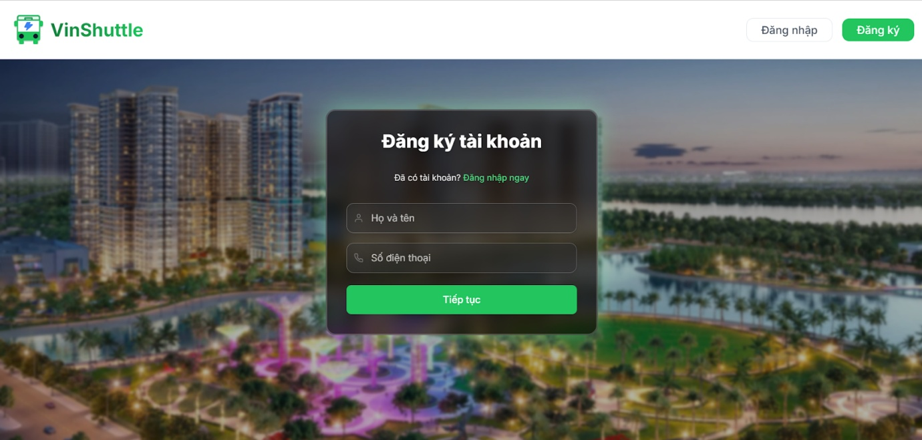

#### 3.2.2 Login

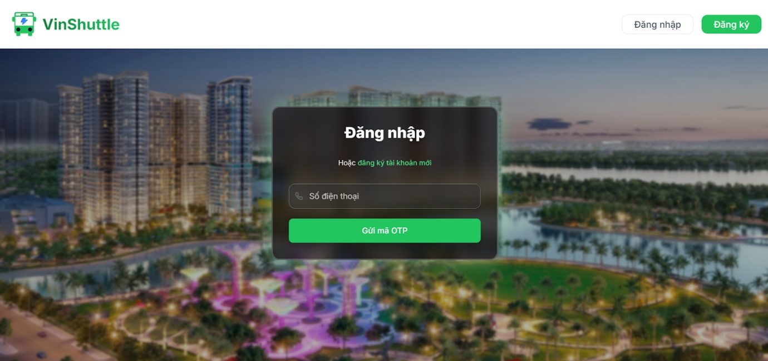

#### 3.2.3 Home page

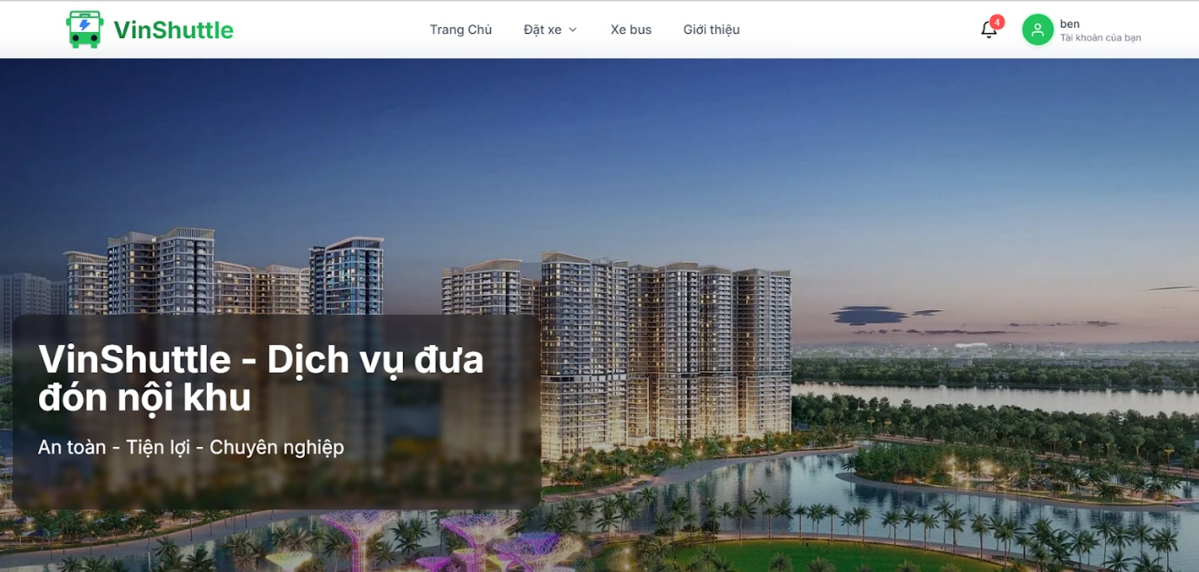

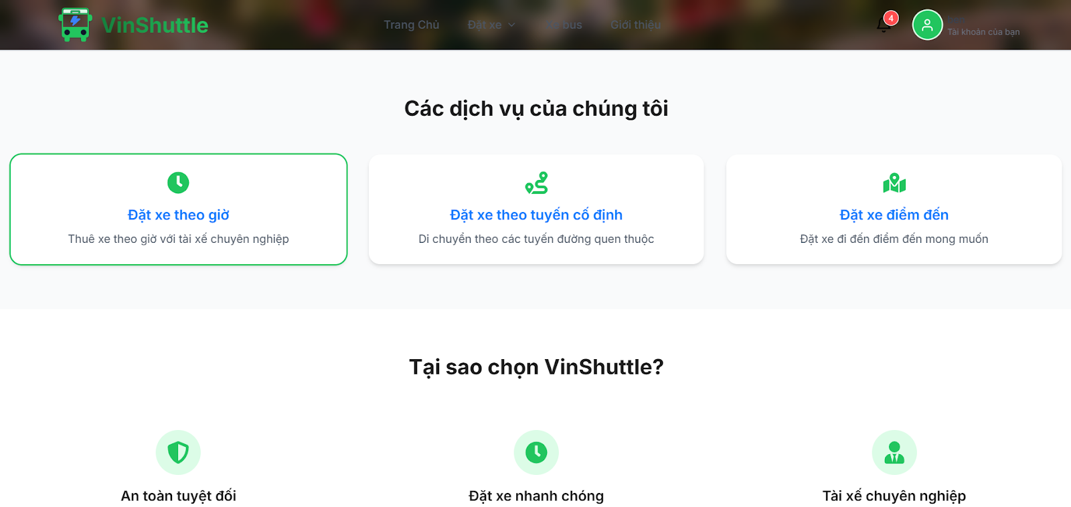

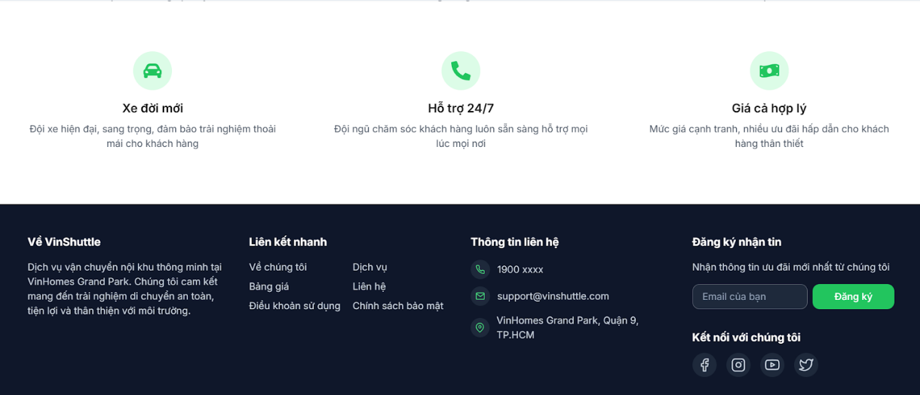

#### 3.2.4 Booking by hours

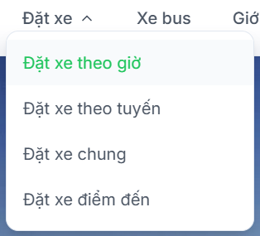

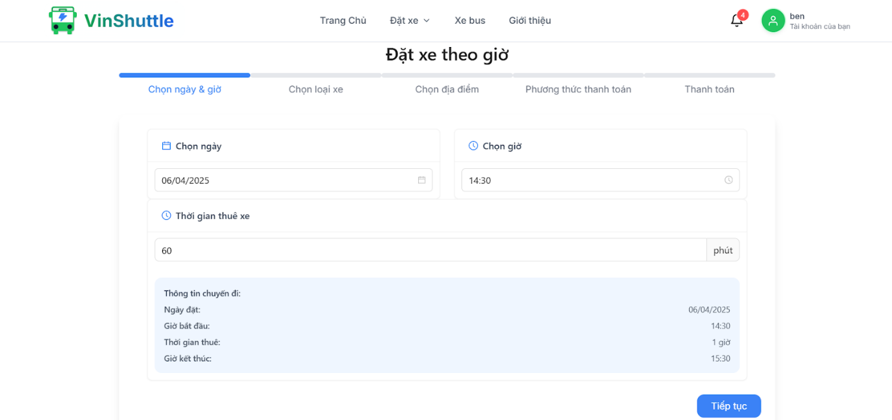

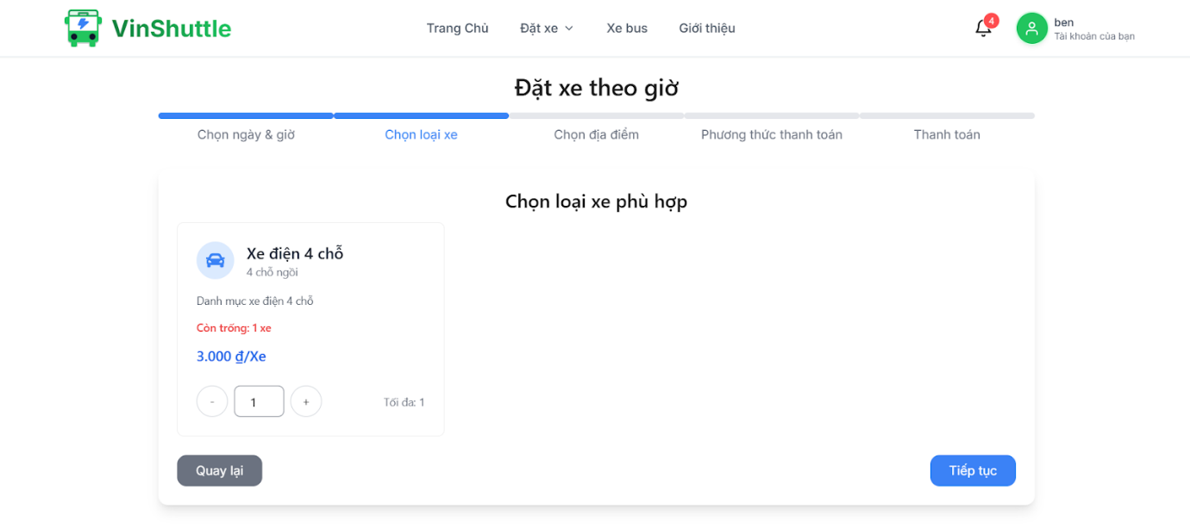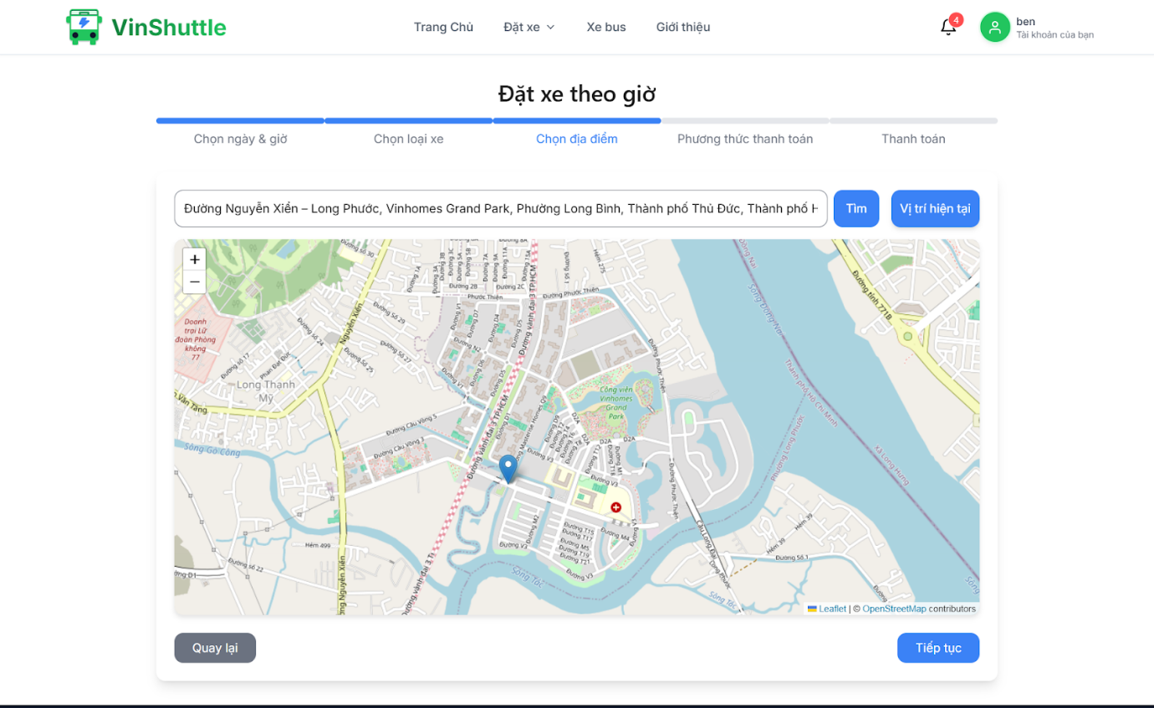

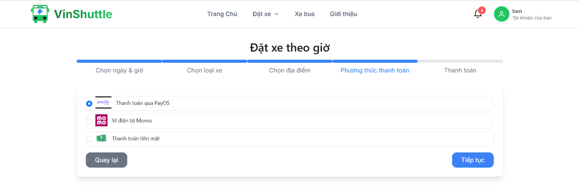

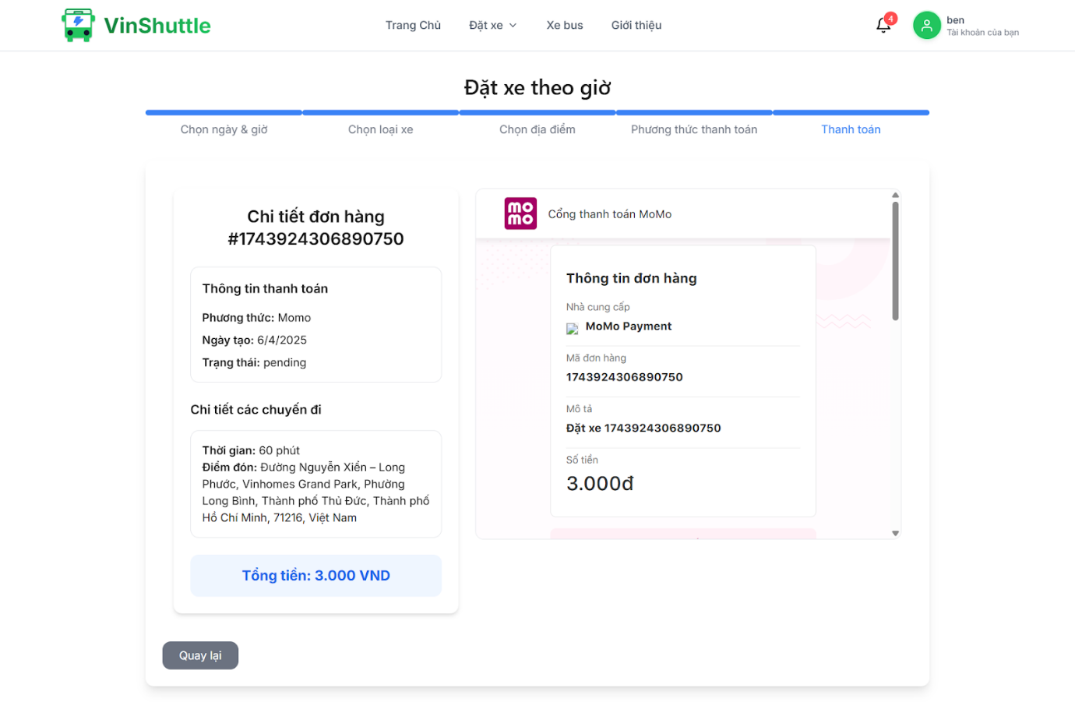

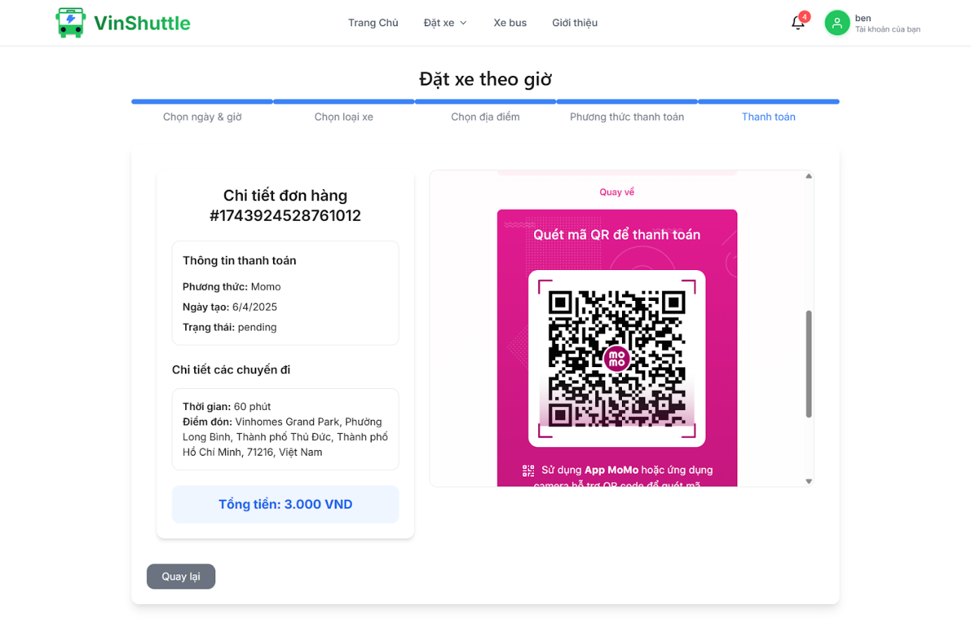

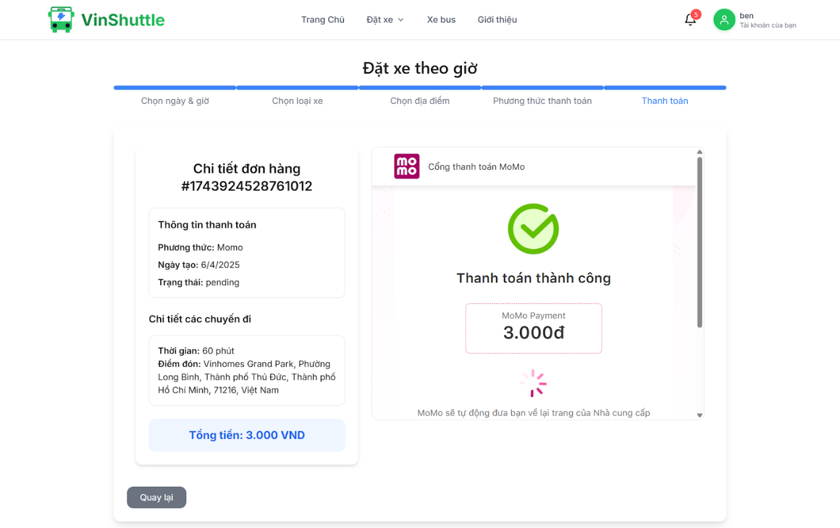

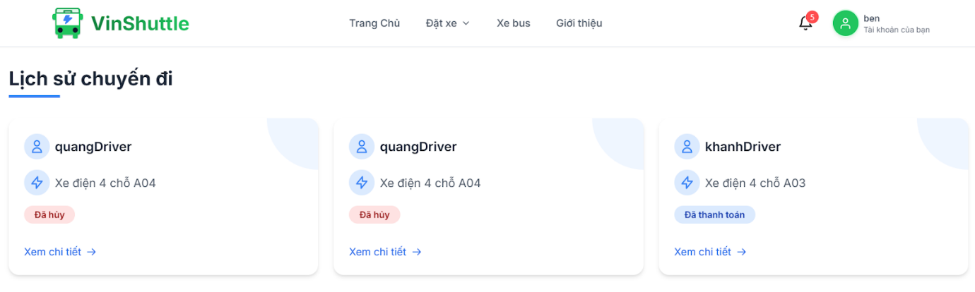

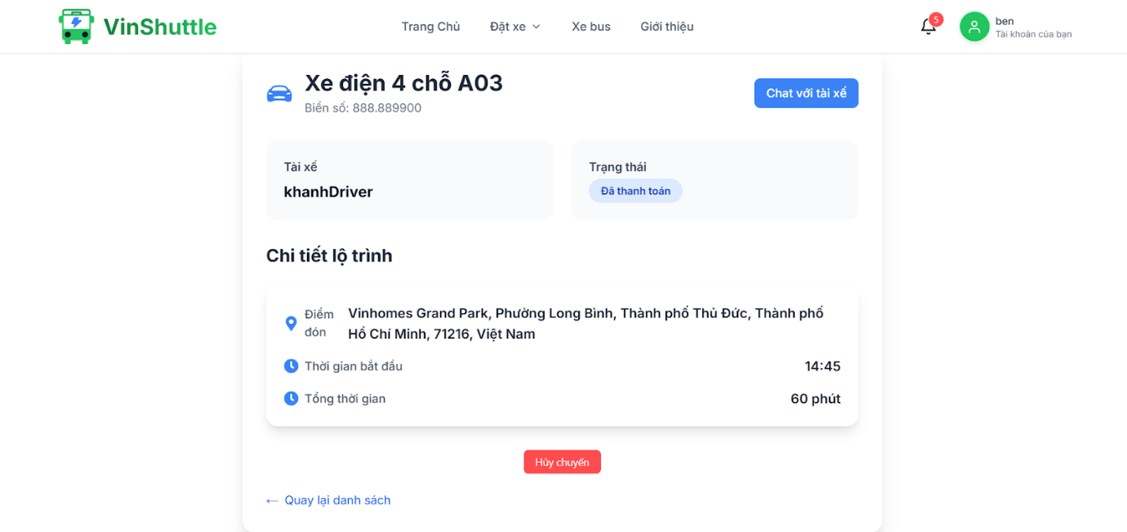

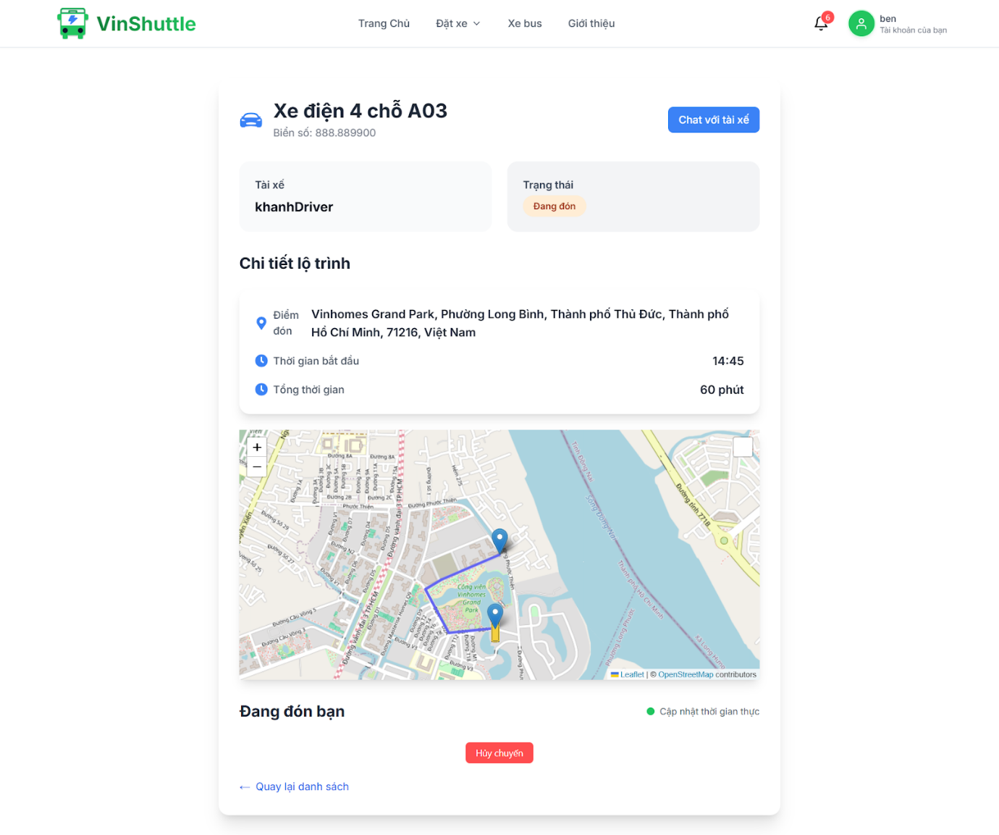

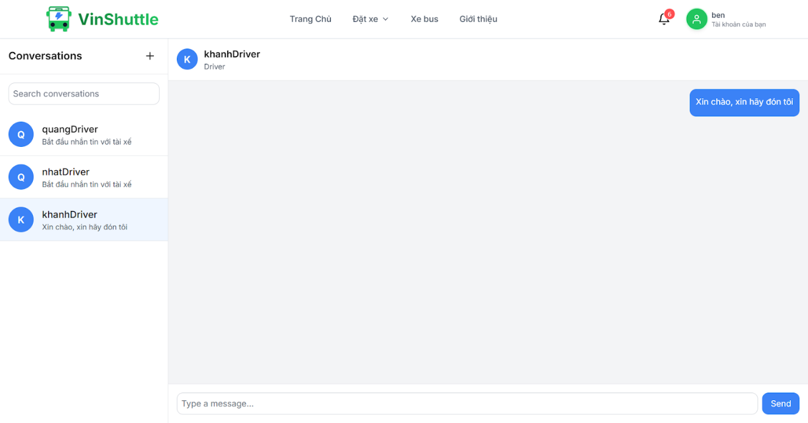

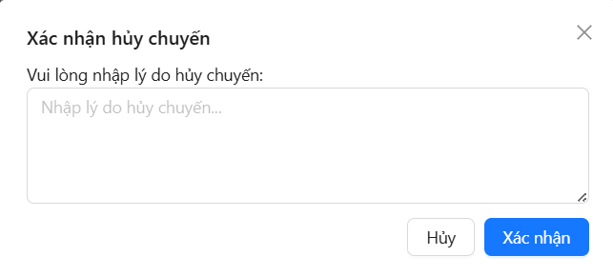

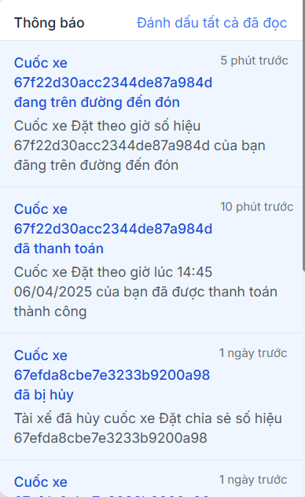

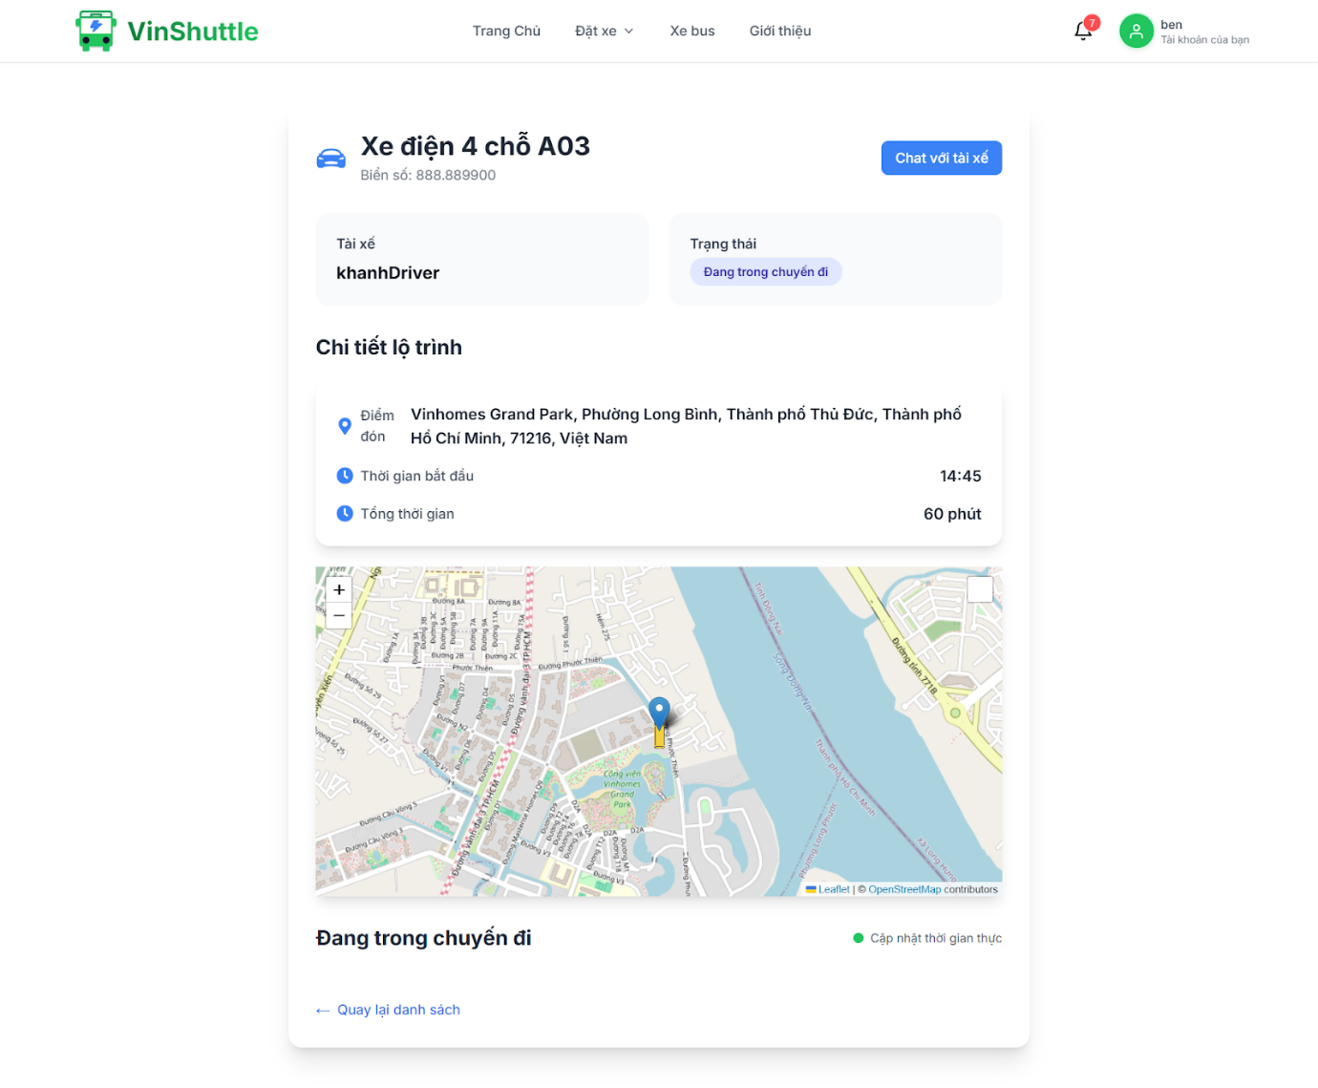

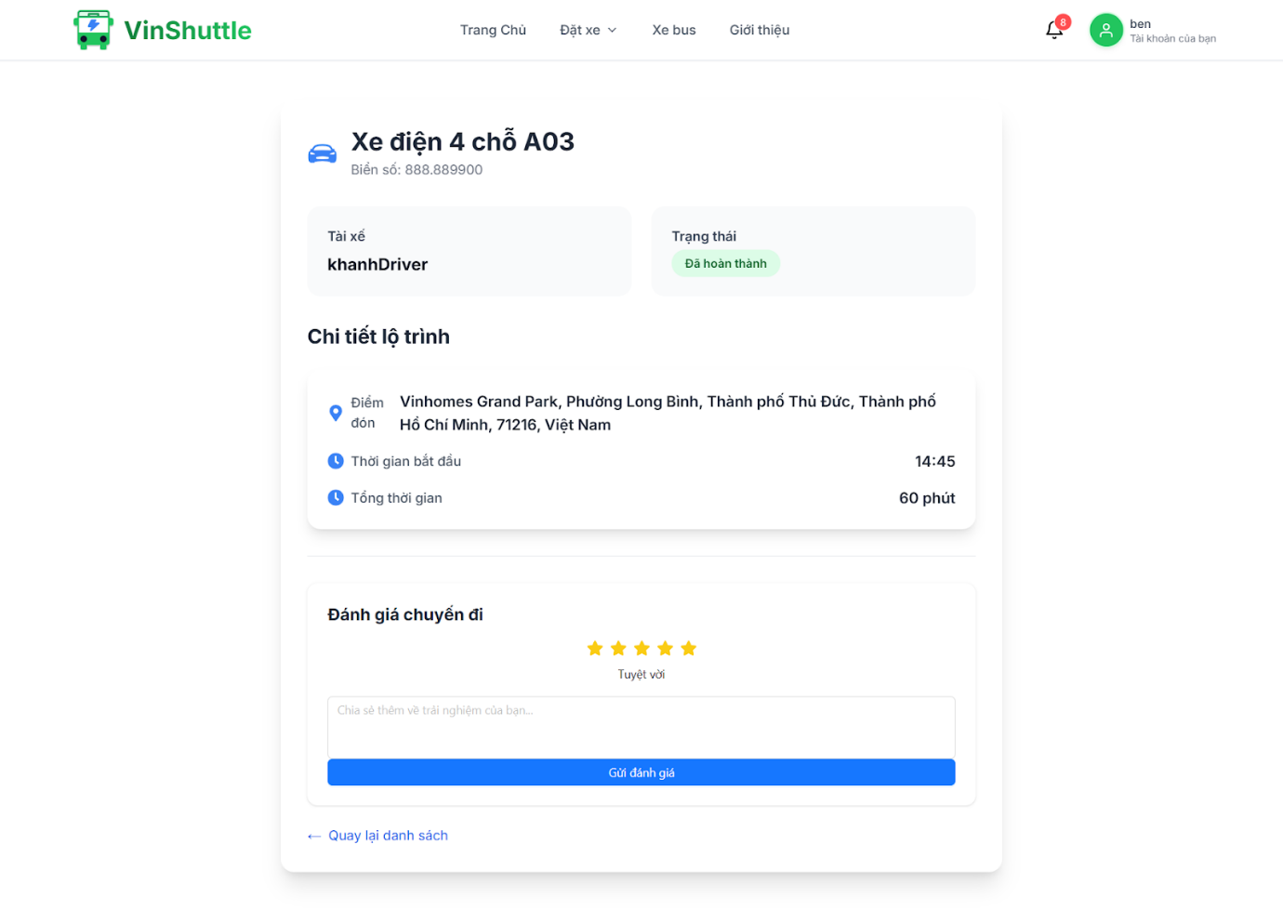

#### 3.2.5 Booking by scenic route

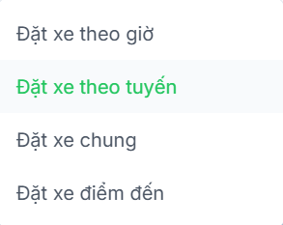

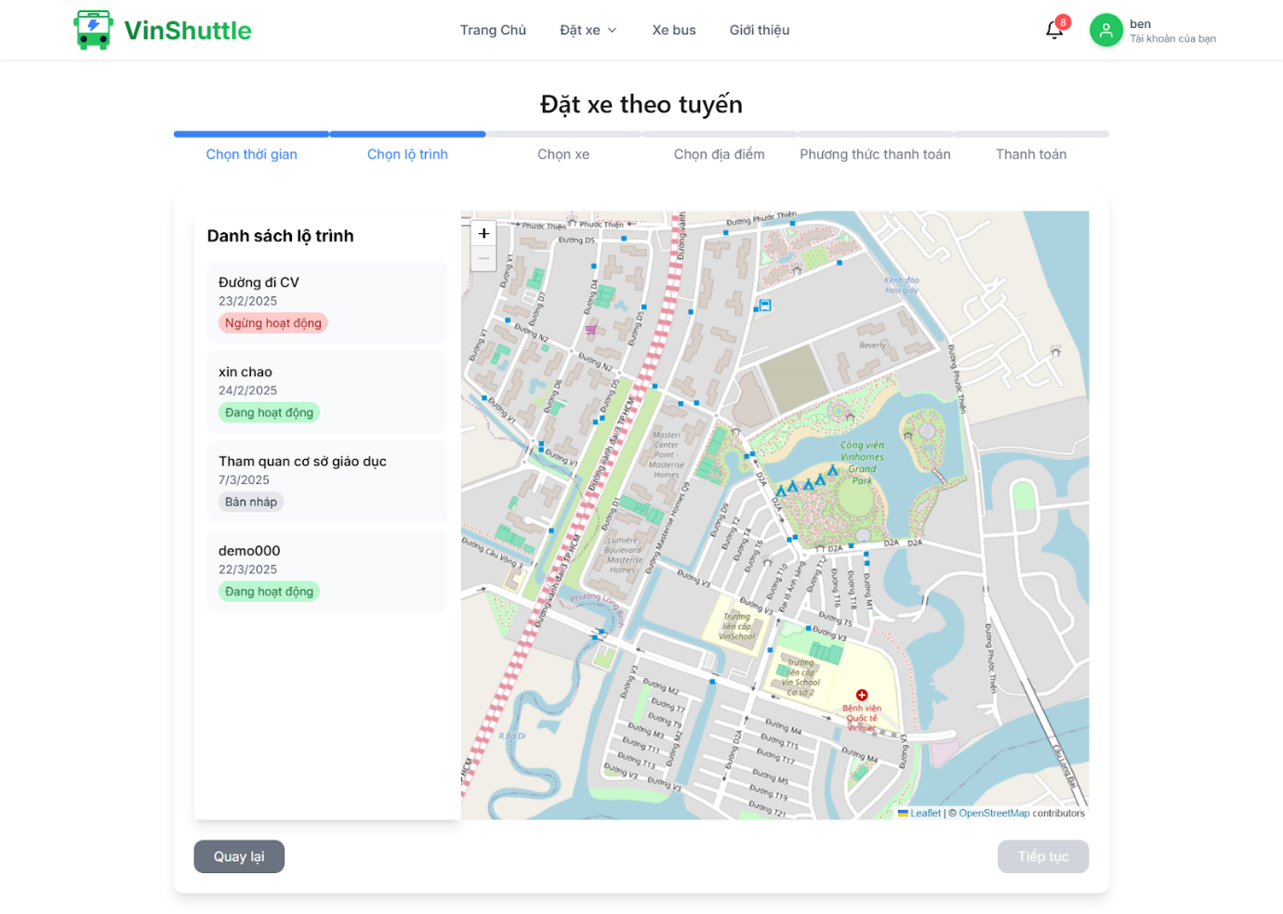

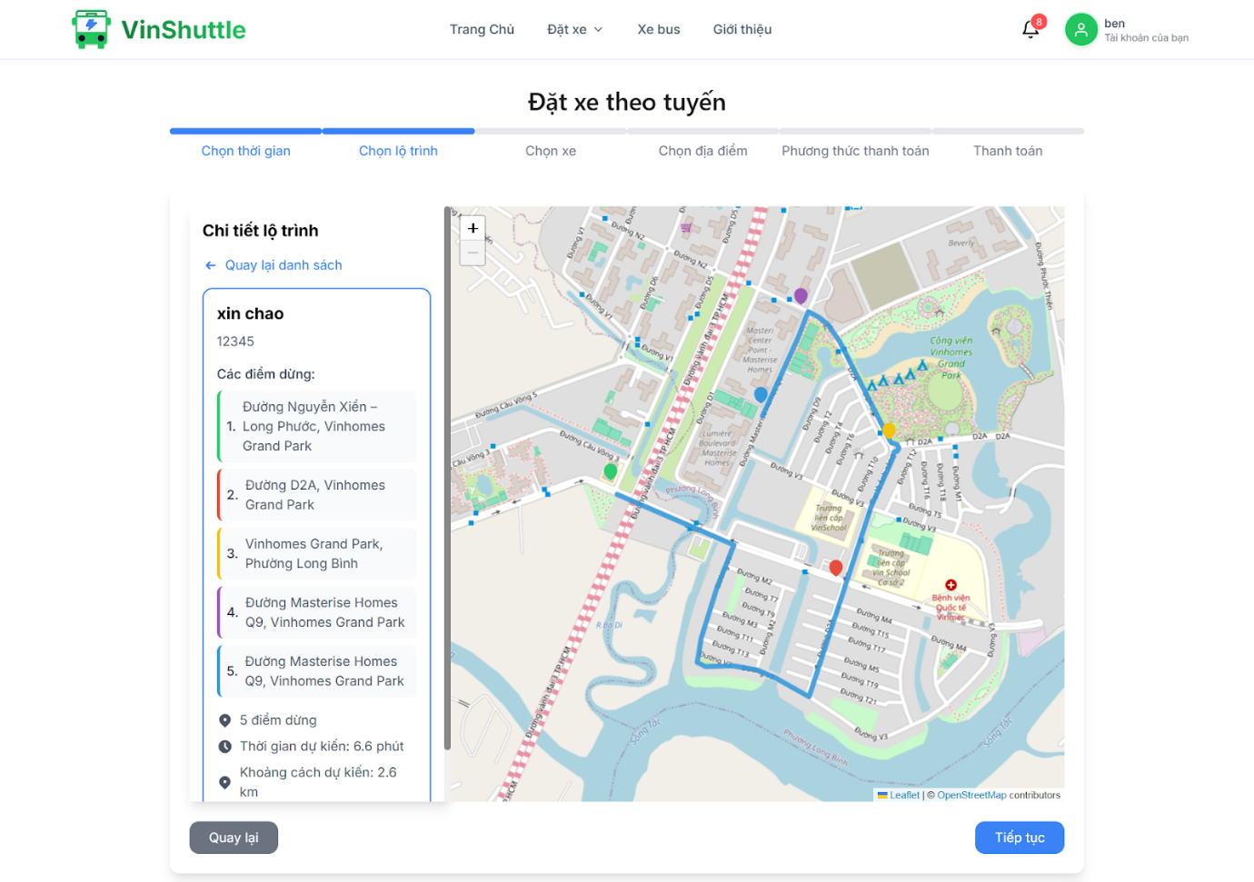

#### 3.2.6 Booking by destination

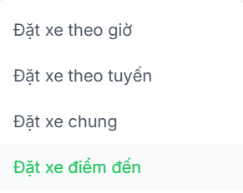

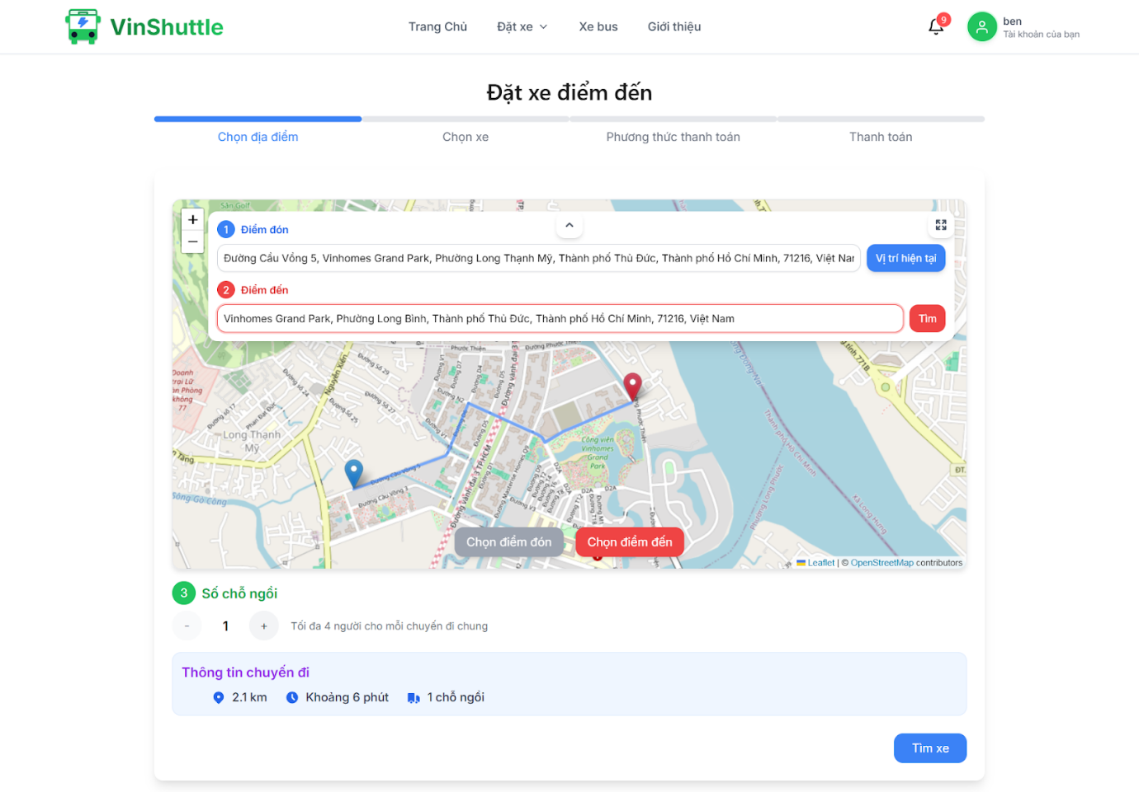

#### 3.2.7 Booking share

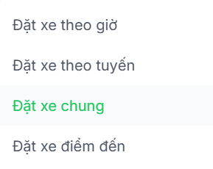

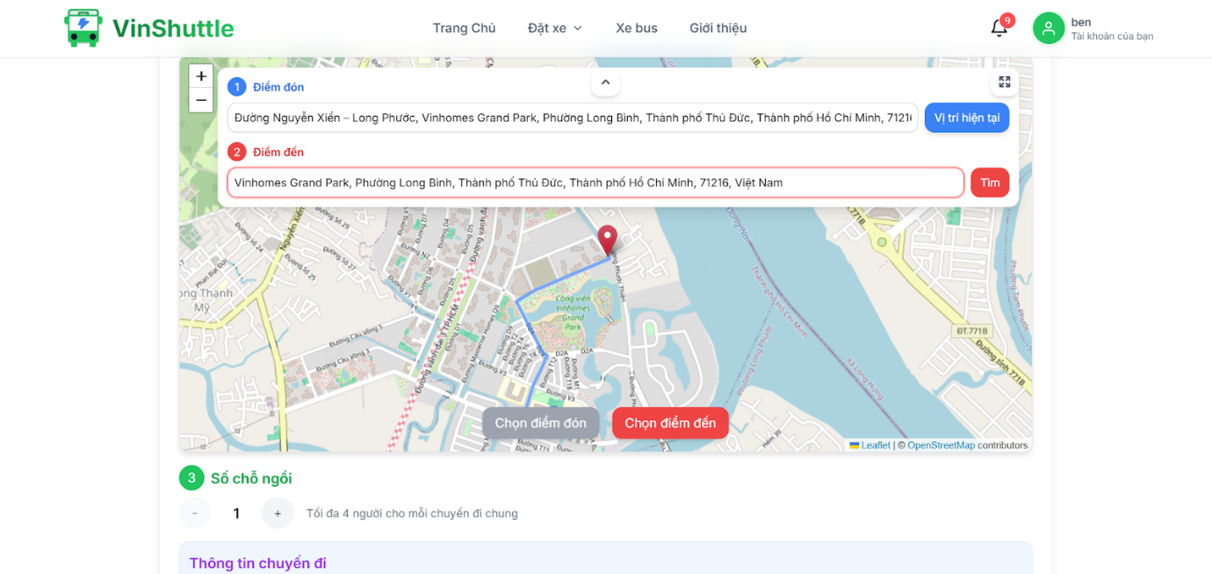

#### 3.2.8 Payment history

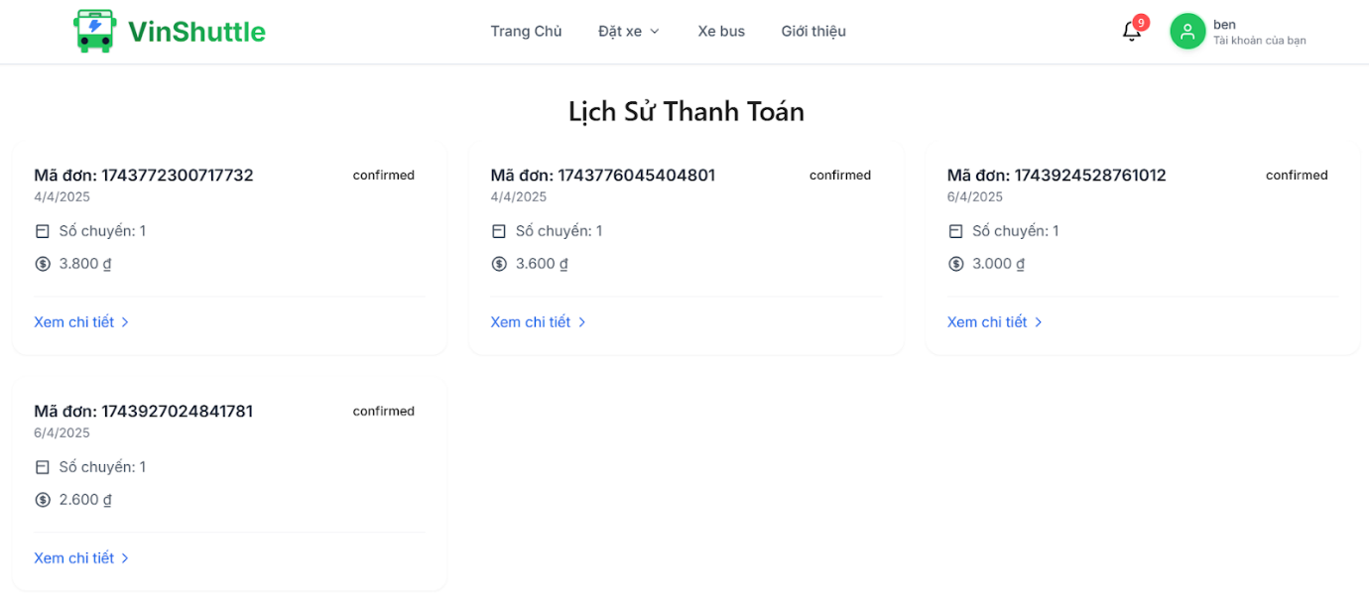

### 3.3 Web manager application features

#### 3.3.1 Login

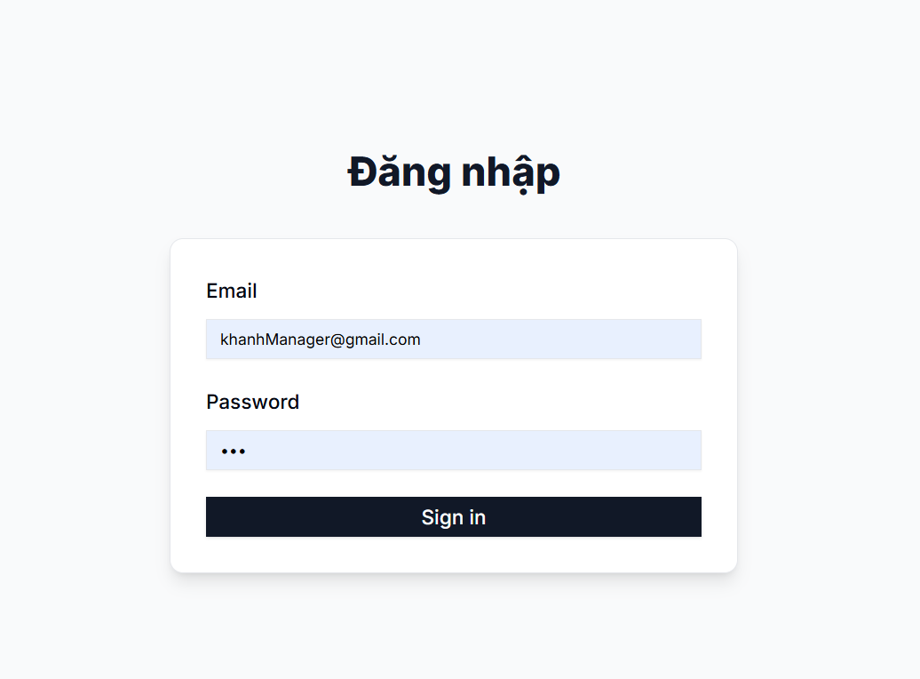

#### 3.3.2 Management driver

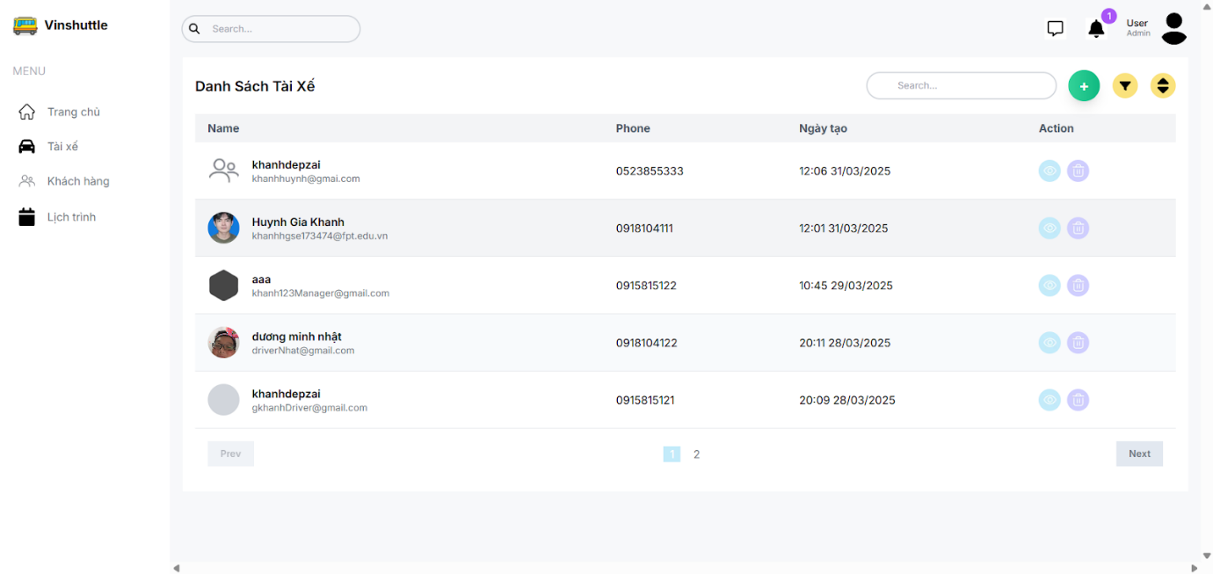

#### 3.3.3 Management customer

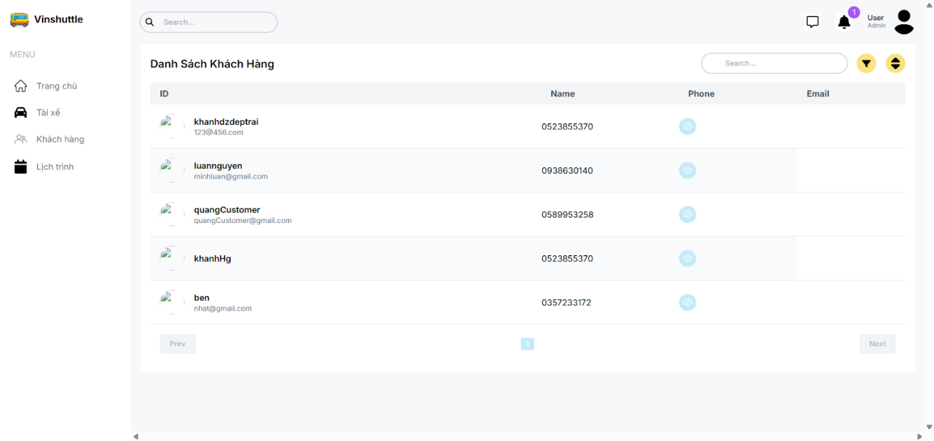

#### 3.3.4 Driver schedule

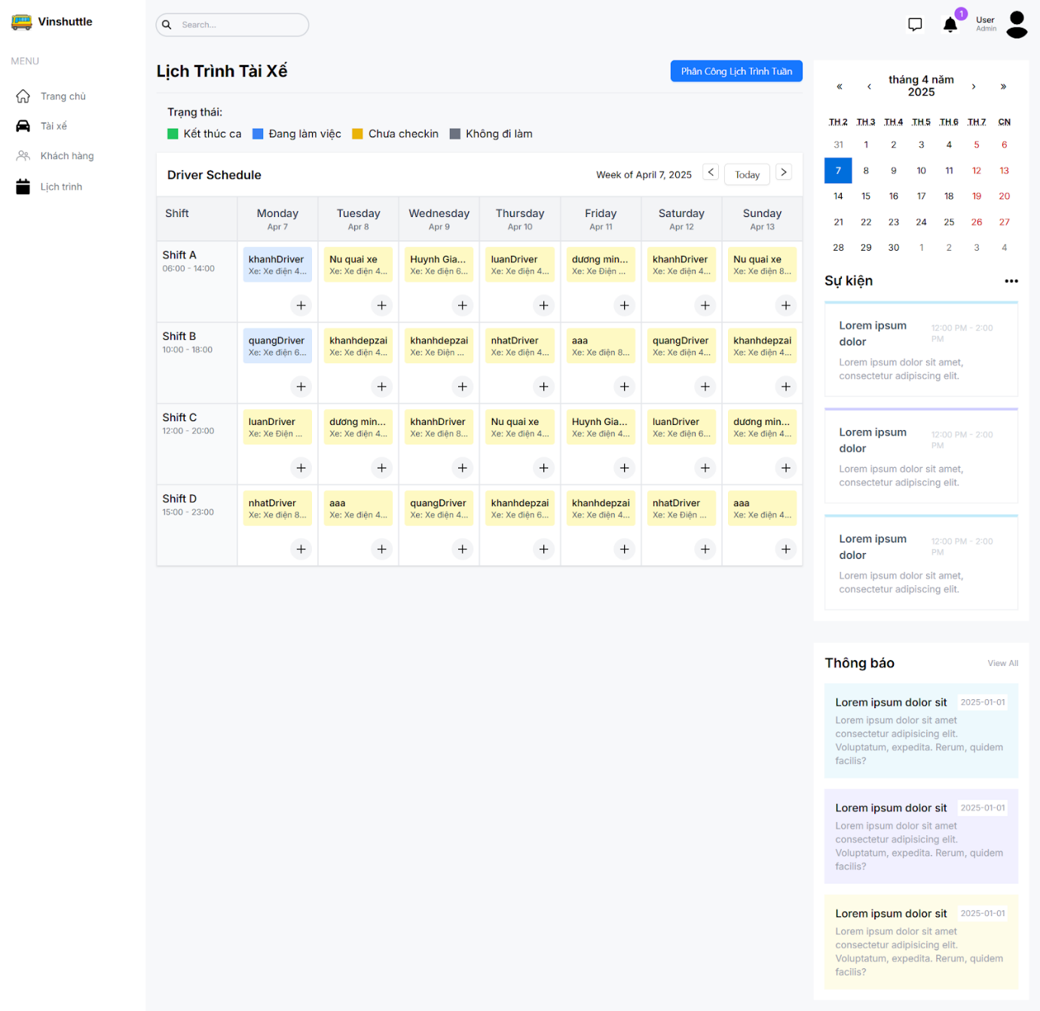

### 3.4 Web admin application features

#### 3.4.1 Login

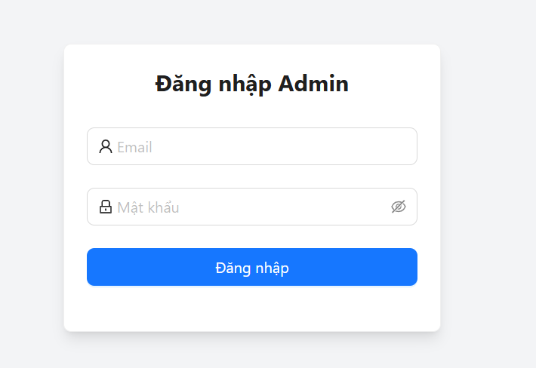

#### 3.4.2 User management

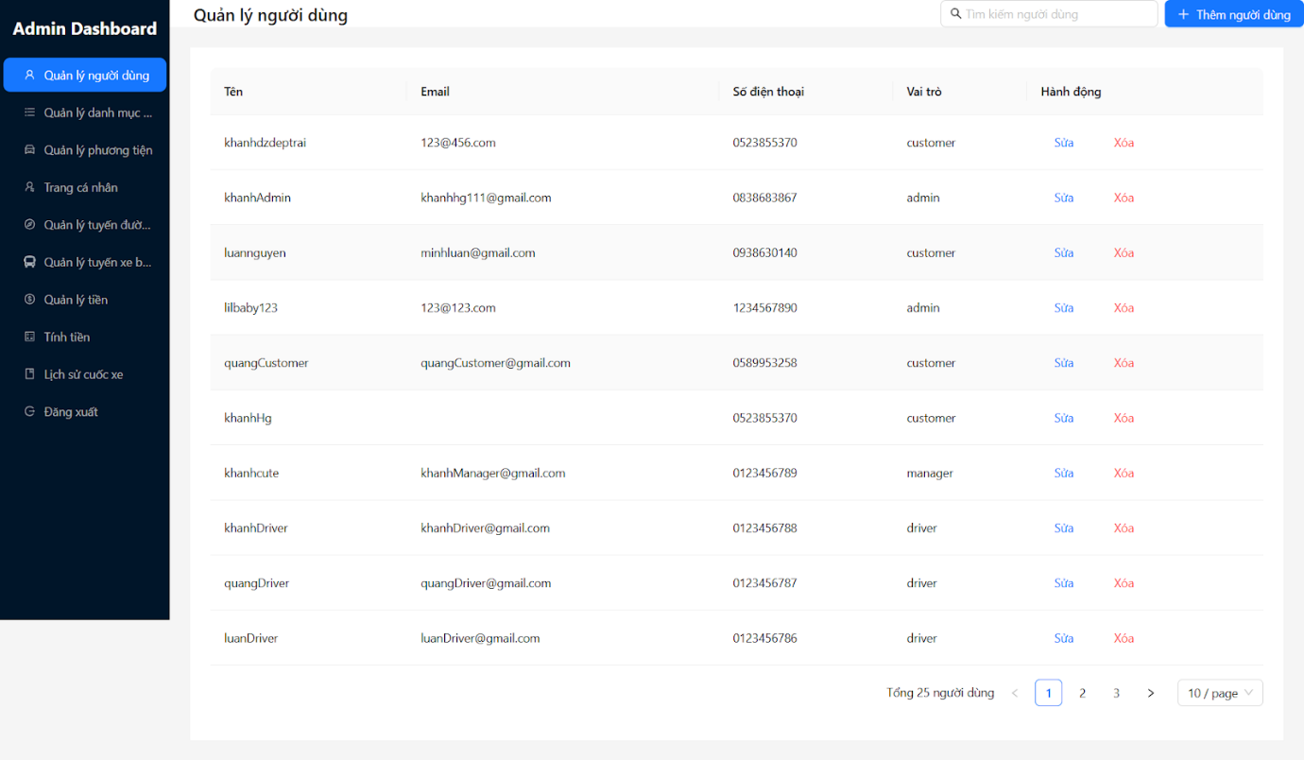

#### 3.4.3 Add user

#### 3.4.4 Category management

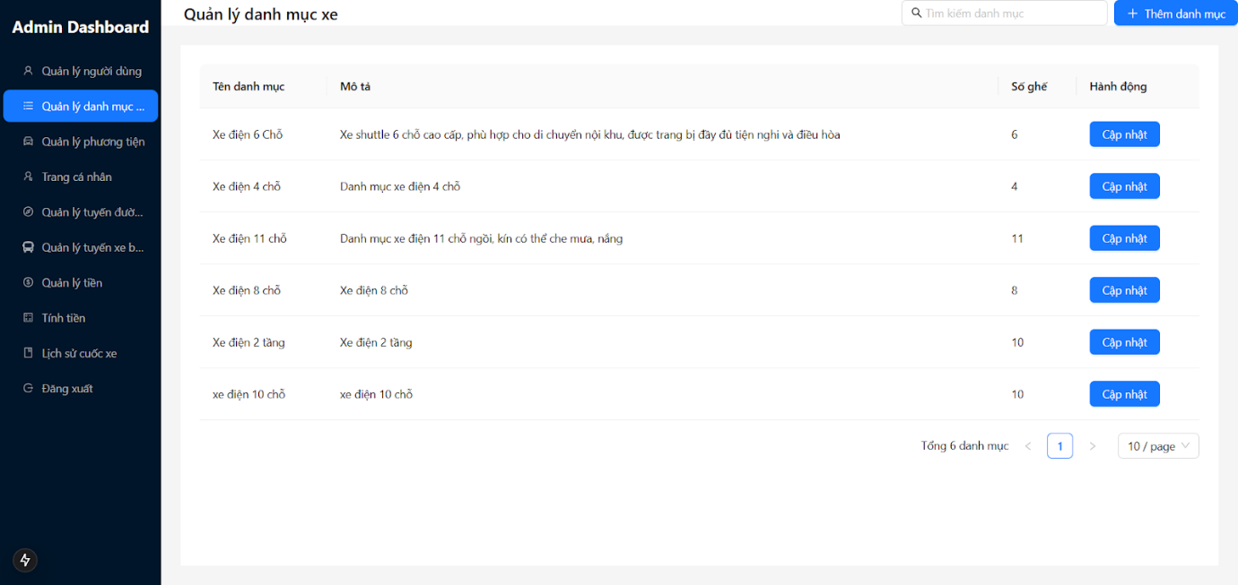

#### 3.4.5 Add category

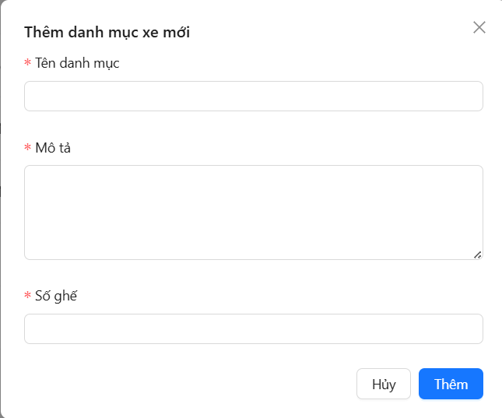

#### 3.4.6 Update category

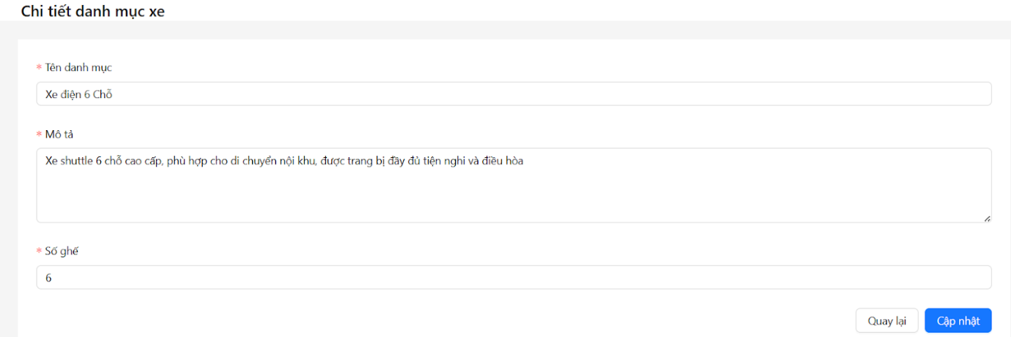

#### 3.4.7 Vehicles management

#### 3.4.8 Add vehicle

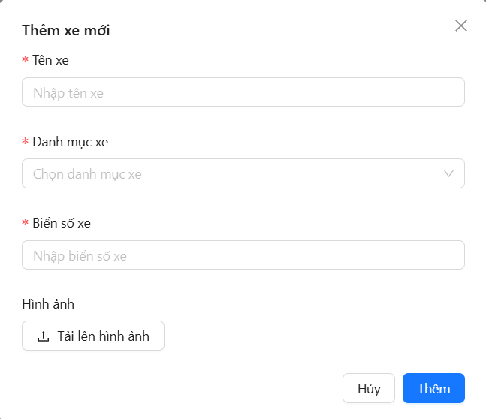

#### 3.4.9 Update vehicle

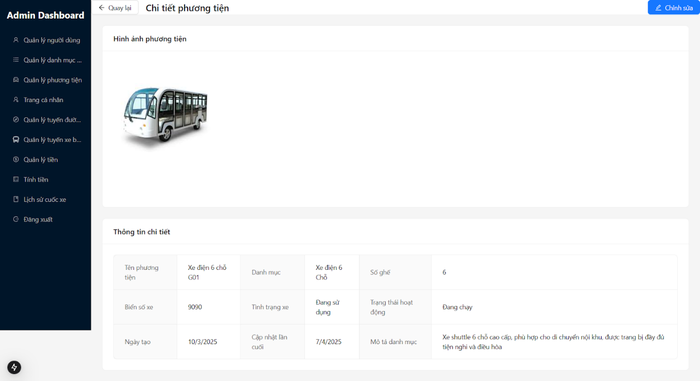

#### 3.4.10 Profile

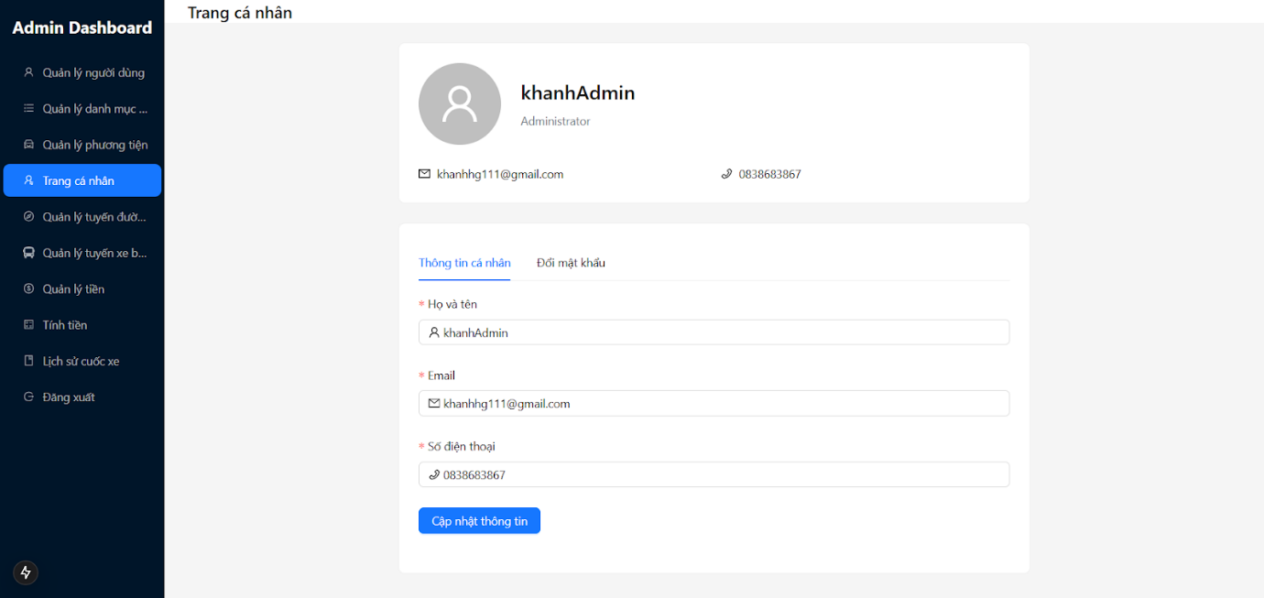

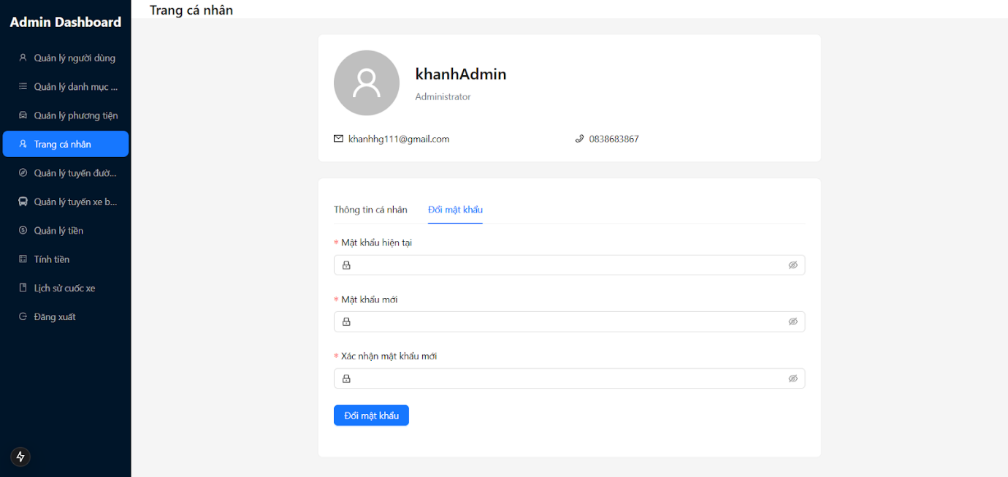

#### 3.4.11 Add scenic route

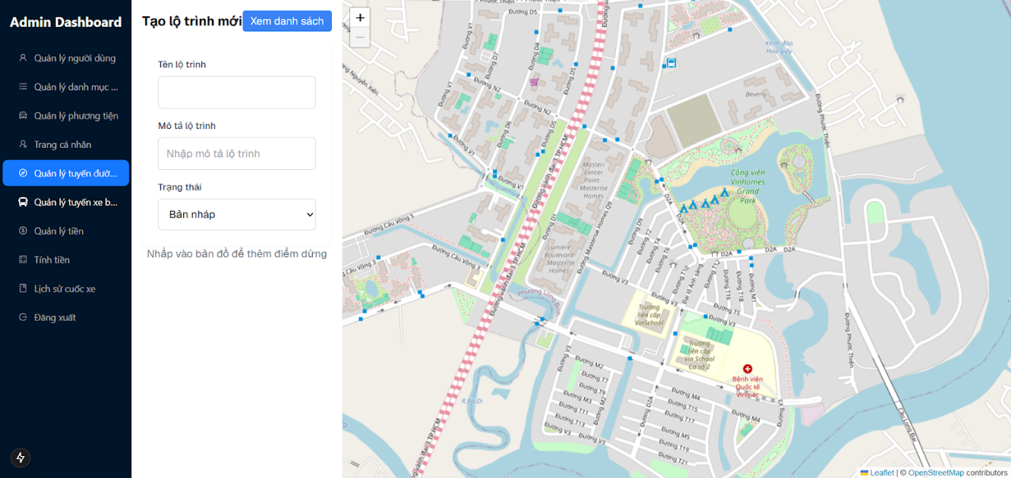

#### 3.4.12 View list route

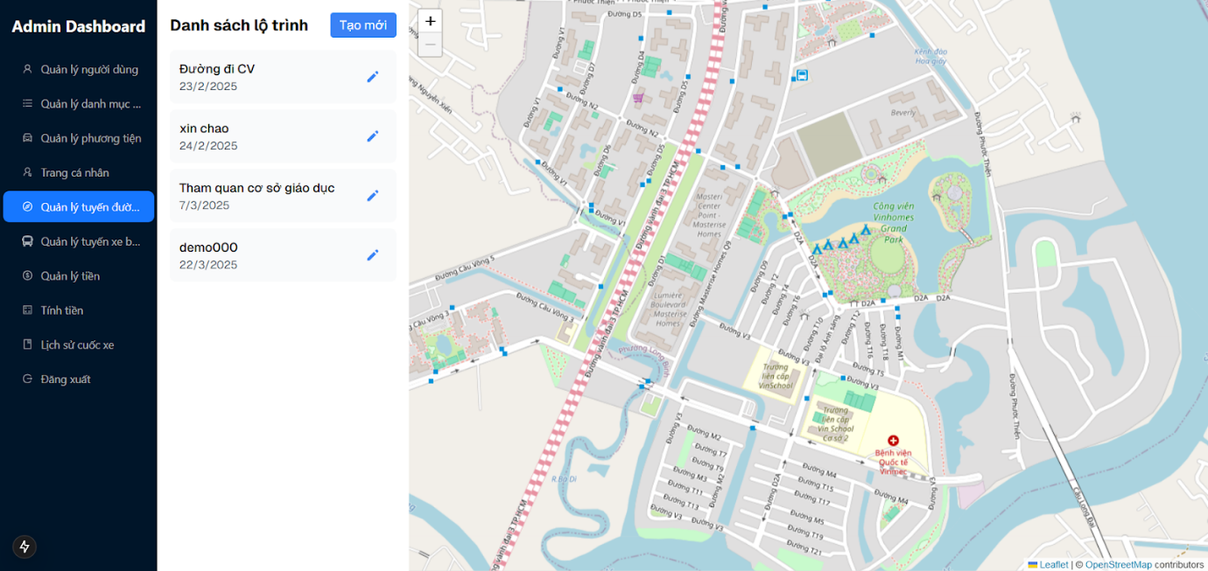

#### 3.4.13 Bus route

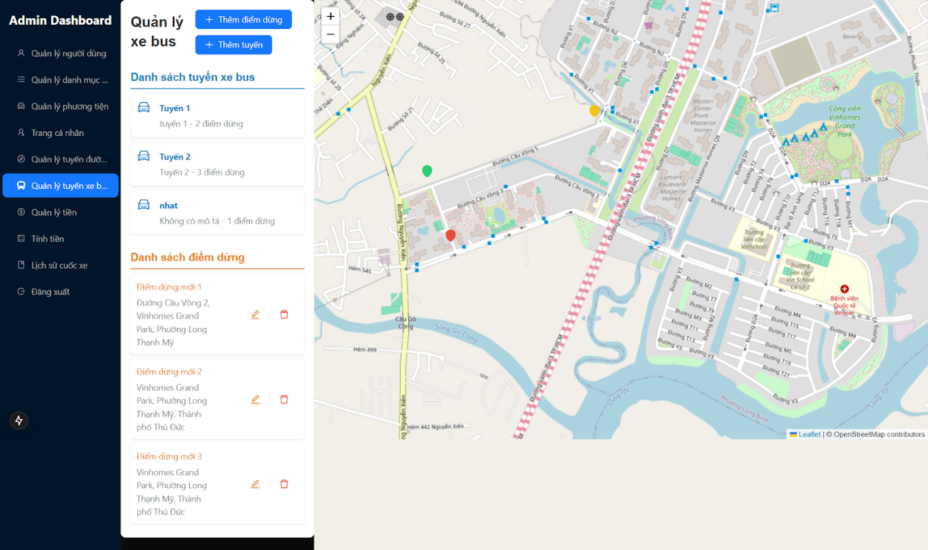

#### 3.4.14 Config management

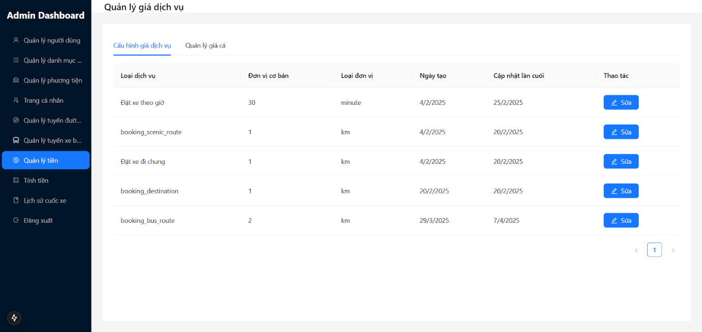

#### 

#### 3.4.15 Money cal

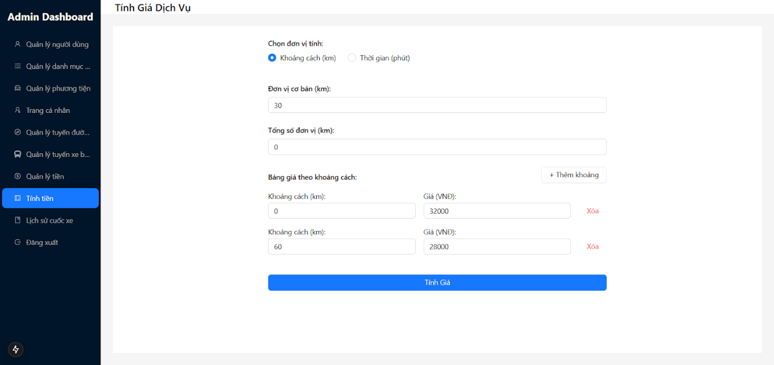

### 3.5 Mobile driver application features

#### 3.5.1 View coming trip

#### 3.5.2 view trip

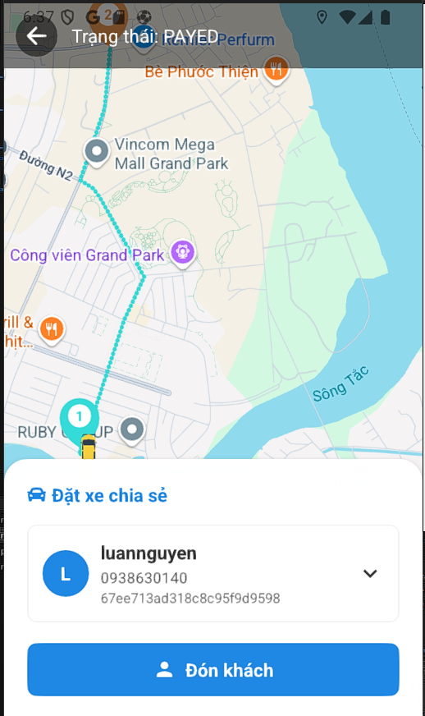

#### 3.5.3 view personal schedule

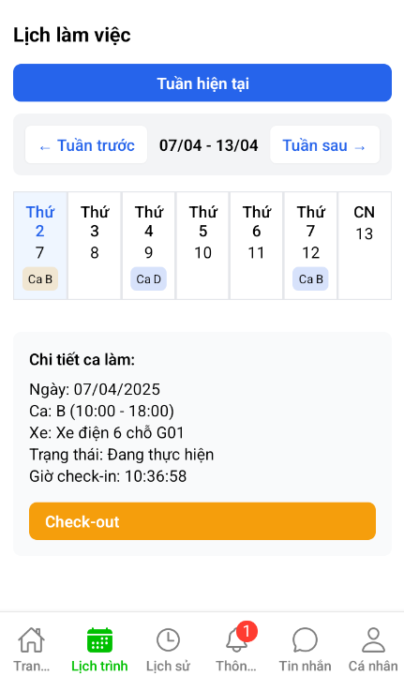

#### 3.5.4 Booking history

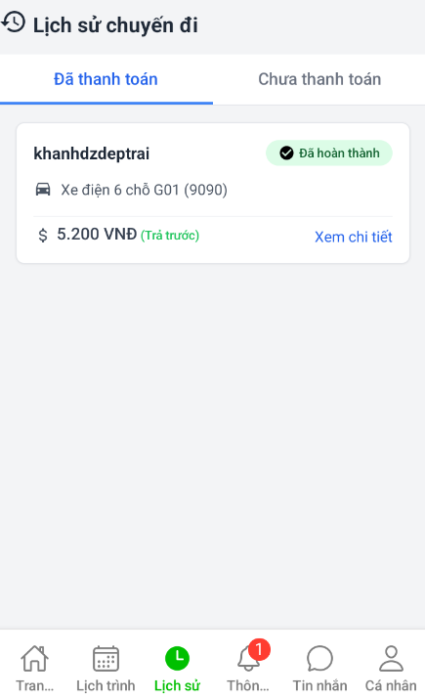

#### 3.5.5 Notification

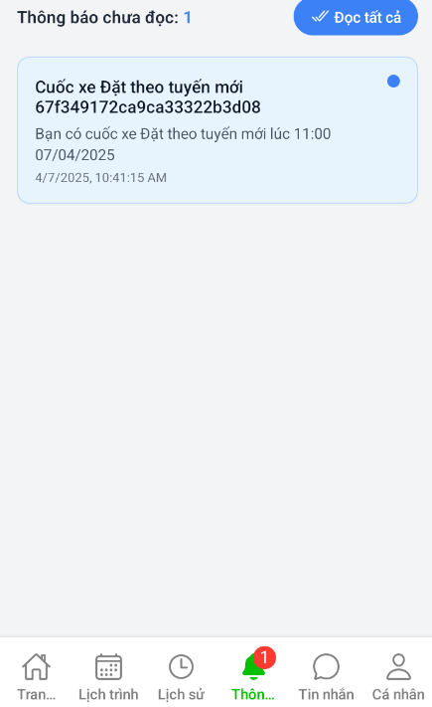

#### 3.5.6 Chat

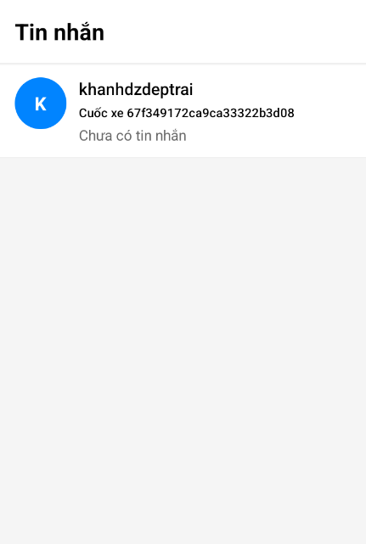

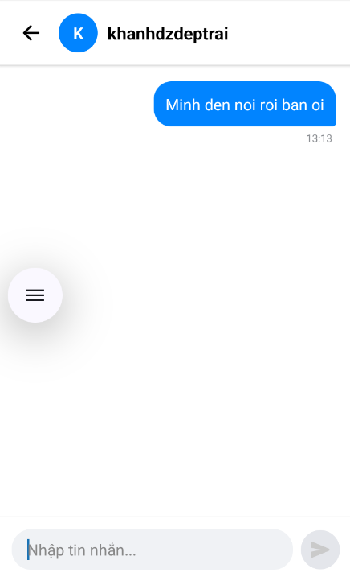

## 4. Non-Functional Requirements

### 4.1 External Interfaces

* **User Interface**: The system must provide an intuitive, responsive UI accessible on various devices, including desktops, tablets, and smartphones.
* **APIs**: The system must integrate with external services such as payment gateways, map services, and third-party authentication providers.
* **Notifications**: The system must support email, SMS, and push notifications for booking confirmations, reminders, and updates.
* **Security**: The system must ensure user data protection through encryption and secure authentication methods.
* **Scalability**: The system must be able to handle an increasing number of users and transactions without performance degradation.
* **Performance**: The system must have a fast response time to user actions, ensuring smooth user interactions.
* **Logging and Monitoring**: The system must provide logging and monitoring capabilities to track system performance and detect anomalies.

### 4.2 Quality Attributes

* **Performance**: The system should respond to user actions within 2 seconds under normal load conditions.
* **Reliability**: The system must have an uptime of over 80% a year to ensure critical services are always available.
* **Security**: Using Third-party to hide API.
* **Usability**: The interface should be user-friendly.
* **Maintainability**: The system architecture supports easy updates.

## 5. Requirement Appendix

### 5.1 Business Rules

|  |  |
| --- | --- |
| ID | Rule Definition |
| BR-01 | User roles must be clearly defined, and access permissions must be enforced based on these roles to ensure appropriate access control |
| BR-02 | Data entered into the system must be validated for integrity prior to processing |
| BR-03 | Admin, Manager, and Driver must have a Google account to login. |
| BR-04 | Each phone number/email is registered to only one account. |
| BR-05 | Customers must have a phone number to login. |
| BR-06 | Customers must verify OTP has been sent to login. |
| BR-07 | OTP is valid for 2 minutes and can only be used once. |
| BR-08 | Only Admin can manage the price of service. |
| BR-09 | Only Admin can manage vehicles. |
| BR-10 | Only Admin can manage Scenic routes. |
| BR-11 | Only Admin can manage Bus routes. |
| BR-12 | Only Admin can view all user information. |
| BR-13 | Only Admin can create a Manager. |
| BR-14 | The Bus routes need more than 2 stations. |
| BR-15 | Only Managers can create drivers. |
| BR-16 | Only Managers and Admin can view all booked trips in the system. |
| BR-17 | Only Managers can edit the driver schedule. |
| BR-18 | Drivers and customers can view their personal trip. |
| BR-19 | A conversation between driver and customer is created automatically after a trip is created. |
| BR-20 | Conversation between driver and customer automatically closes 24 hours after the trip ends. |
| BR-21 | Drivers can only view their personal schedule. |
| BR-22 | Drivers can edit their profile. |
| BR-23 | Driver can view the rate and feedback of the trip. |
| BR-24 | Drivers will only receive bookings if there are no scheduled trips and are on shift. |
| BR-25 | Drivers must check-in before shift and check out after shift. |
| BR-26 | Driver cannot check-out if the trip is unfinished. |
| BR-27 | Shifts can last up to 15 minutes if a trip is in progress. |
| BR-28 | The vehicle's operating status is automatically updated when the vehicle has a trip, ends a trip, changes shifts, etc. |
| BR-29 | System response vehicles suitable for customer needs. |
| BR-30 | Customers can edit their profile. |
| BR-31 | Customers can only see the vehicle's location during the current trip. |
| BR-32 | Customers can only view Scenic Routes and Bus Routes that have been made public |
| BR-33 | Customers can only see the locations of all running buses of the Bus Route service. |
| BR-34 | Customers need to provide a pick up point when booking. |
| BR-35 | Customers are only rated after the trip is completed. |
| BR-36 | Car/driver can only be booked if the status is active. |
| BR-37 | Share a ride on demand, route changes do not exceed 50%  per trip distance in share Itinerary |
| BR-38 | Rent by hour and Rent by Scenic route must be paid in advance. |
| BR-39 | Rent by hour must have a minimum duration of 0.5 hours and a maximum of 5 hours. |
| BR-40 | With Rent by hour and Rent by Scenic route, Customers can only cancel flights 2 hours before departure time. |
| BR-41 | The number of people participating in the shared trip must not exceed the maximum number of seat. |
| BR-42 | Bus routes are only visible to customers if they have been approved and made public by the Admin. |
| BR-43 | If online payment is selected, payment must be completed before the trip can start. |

### 5.2 Common Requirements

The system must perform automated daily data backups to ensure the safety of user information.

Online help features and tooltips powered by AI must be implemented to enhance the user experience.

The system must meet specific performance standards under both normal and peak load conditions.

User interfaces must comply with usability standards to ensure an understandable experience for all user types, including Administrators, Manager, and Customers, Driver.

### 5.3 Application Messages List

|  |  |  |  |  |
| --- | --- | --- | --- | --- |
| **#** | **Message code** | **Message Type** | **Context** | **Content** |
| 1 | MSG01 | In red, under the text box | User forgot to input email or password | Email and password is required |
| 2 | MSG02 | In line | User is empty | No user data found |
| 3 | MSG03 | In line | Search empty | No data found |
| 4 | MSG04 | In line | Request is empty | No request found |
| 5 | MSG05 | Toast message | Accept request | Accepted |
| 6 | MSG06 | Toast message | Reject request | Rejected |
| 7 | MSG7 | Toast message | User role is not allow to sign in the application | This account doesn’t have permission to access this application |
| 8 | MSG8 | Toast message | Email or password is not existed | Email is not existed or password is not correct |
| 9 | MSG9 | In red, under the text box | User enter an invalid email | Please enter a valid email address |
| 10 | MSG10 | In red, under the text box | User enter a password with less than 5 characters | Password must have more than 5 characters |
| 11 | MSG11 | Toast message | Create successfully | Create successfully |
| 12 | MSG12 | Toast message | Create unsuccessfully | Cannot create |
| 13 | MSG13 | Toast message | Update successfully | Update successfully |
| 14 | MSG14 | Toast message | Update unsuccessfully | Cannot update |